Unit 6 Table of Contents
Interpretation Text Sets

Section | Page #
- Unit Goals and Standards | 2-3
- Unit 6 at a Glance | 4-5
- English/Spanish/Russian Monthly Planner | 6-7
- Assessment Checklist

Lesson | Lesson Title | Page #
Lesson 1 | Readers learn life lessons by revisiting texts. (p.114 p. 126) 5.RML.6-1 | 8-10
Lesson 2 | Readers learn significant lessons by paying attention to characters strong emotions or critical choices | 11-12
Lesson 3 | Readers revise original ideas as the story develops by gathering evidence. | 13-15
Lesson 4 | Readers can find similar ideas across multiple texts by comparing text they have already read | 16-18
Lesson 5 | Readers recognize differences in similar text by focusing on setting and how it affects the meaning. | 19-20
Lesson 6 | Readers develop systems to help them recall text by creating a graphic organizer to note similarities, differences and how it affects our ideas. | 21-23
Lesson 7 | Readers analyze differences in characters by paying attention to character traits. | 24-26
Lesson 8 | Readers learn from characters by noticing how characters respond to different challenges and apply what they learn to their own lives | 27-28
Lesson 9 | Readers process the story by keeping track of what is happening and adding on new information. | 29-31
Lesson 10 | Readers understand deeper significances in their texts by thinking about objects that repeat. | 32-34
Lesson 11 | Readers add to their symbolic understanding of the text by thinking about the potential meanings of titles. | 35-37
Lesson 12 | Readers understand that details matter by figuring out the possible meanings with perplexing or unexplained details. | 38-39
Lesson 13 | Readers better understand the significance of repetition by thinking, reading and writing about its potential meanings. | 40-42
Lesson 14 | Readers find deeper meanings in text by analyzing characters’ perspectives and points of view | 43-44

Grade 5 Reading Unit 6  Unit of Study Planning Template | Dates  April 12-May 7

Unit: | Interpretation Text Sets

Goals:  (These should align with Essential Questions. Each goal is developed in the following planning pages- one per goal.) | - Considering the implications of stories.  - Themes may be the same across book, but they’re usually develop differently  - Symbolism and literary devices and their relationship to the meanings and themes of stories.

Essential Questions:
(These should be aligned with Goals.)

Standards: | 5.RL.1 Quote accurately from a text when explaining what the text says,  explicitly and when drawing inferences from the text.  5.RL.2 Determine a theme of a story, drama, or poem from details in the text, including how characters in a story or drama respond to challenges or how the speaker in a poem reflects upon a topic; summarize the text.  5.RL.3 Compare and contrast two or more characters, settings, or events in a story or drama, drawing on specific details in the text (e.g., how characters interact).  5.RL.4 Determine the meaning of words and phrases as they are used in a text, including figurative language such as metaphors and similes.  5.RL.5 Explain how a series of chapters, scenes, or stanzas fits together to provide the overall structure of a particular story, drama, or poem.  5.RL.6 Describe how a narrator’s or speaker’s point of view influences how events are described.  5.RL.9 Compare and contrast stories in the same genre (e.g., mysteries and adventure stories) on their approaches to similar themes and topics.  5.RL.10 By the end of the year, read and comprehend literature, including stories, dramas, and poetry, at the high end of the grades 4–5 text complexity band independently and proficiently.  5.W.9 Draw evidence from literary or informational texts to support analysis, reflection, and research.  - Apply grade 5 Reading standards to literature (e.g., “Compare and contrast two or more characters, settings, or events in a story or a drama, drawing on specific details in the text [e.g., how characters interact]”).  5.SL.1 Engage effectively in a range of collaborative discussions (one-on-one, in groups, and teacher-led) with diverse partners on grade 5 topics and texts, building on others’ ideas and expressing their own clearly.  - Come to discussions prepared, having read or studied required material; explicitly draw on that preparation and other information known about the topic to explore ideas under discussion.  - Follow agreed-upon rules for discussions and carry out assigned roles.  - Pose and respond to specific questions by making comments that contribute to the discussion and elaborate on the remarks of others.  - Review the key ideas expressed and draw conclusions in light of information and knowledge gained from the discussions.

Key Vocabulary: | Literary devices, analyze, synthesize, symbol, symbolism, evidence, pivotal moment, implication, setting, perspective, traits, background, perplexing, challenge, obstacle, revision, revisable, shift, deception, metaphor, foreshadowing, insights, interpretation, potential

Anchor Texts: | Number the Stars by Lois Lowry, Pink and Say by Patricia Polacco, The Giver by Lois Lowry, Esperanza Rising by Pam Munoz Ryan, Hatchet by Gary Paulson

Other Resources: | - WWII Image Powerpoint

Assessment:  (Including CCSS performance task.) | FORMATIVE | SUMMATIVE
 | - Running records, anecdotal notes, check lists | - DRAs, IRIs

Unit of Study at a Glance Planner

Unit 6: Interpretation Text Sets
GOAL:  Considering the implications of stories. | GOAL:  Themes may be the same across book, but they’re usually developed differently. | GOAL:  Symbolism and literary devices and their relationship to the meanings and themes of stories.
MINILESSONS: | MINILESSONS: | MINILESSONS:
- Readers learn life lessons by revisiting texts. (p.114 p. 126) 5.RML.6-1  - Readers learn significant lessons by paying attention to the characters’ life changing events. (p. 115p. 126) 5.RML.6-2  - Readers revise original ideas as the story develops by gathering evidence. (p.114-115 p. 126) 5.RML.6-3  Readers can find similar ideas across multiple texts by comparing text they have already read. (p.116-117 p. 126) 5.RML.6-4 | - Readers recognize differences in similar text by focusing on setting and how it affects the meaning. (p.119 p.126) 5.RML.6-5  - Readers develop systems to help them recall text by creating a graphic organizer to note similarities, differences and how it affects our ideas. (p.119 p. 126-127) 5.RML.6-6  - Readers analyze differences in characters by paying attention to character traits. (p.120 p. 127) 5.RML.6-7  - Readers learn from characters by noticing how characters respond to different challenges and apply what they learn to their own lives (p.120 p. 127) 5.RML.6-8  - Readers process the story by keeping track of what is happening and adding on new information. (p.120 p. 127) 5.RML.6-9 | - Readers understand deeper significances in their texts by thinking about objects that repeat.(p.120-121 p. 127) 5.RML.6-10  - Readers add to their symbolic understanding of the text by thinking about the potential meanings of titles. (p.121 p. 127) 5.RML.6-11  - Readers understand that details matter by figuring out the possible meanings with perplexing or unexplained details. (p.121-122 p. 127) 5.RML.6-12  - Readers better understand the significance of repetition by thinking, reading and writing about its potential meanings. (p. 122p. 128) 5.RML.6-13  - Readers find deeper meanings in text by analyzing characters’ perspectives and points of view. (p.123 p. 128) 5.RML.6-14

WORKSHOP CALENDAR FOR: | Grade 5 Reading Unit 6 | Dates: April 12-May 7
Unit of Study: Unit 6 | Interpretation Text Sets

MONDAY | TUESDAY | WEDNESDAY | THURSDAY | FRIDAY
12
Readers learn life lessons by revisiting texts. 5.RML.6-1

15  Readers learn significant lessons by paying attention to the characters’ life changing events. 5.RML.6-2 | 16  Readers revise original ideas as the story develops by gathering evidence. 5.RML.6-3 | 17  Readers revise original ideas as the story develops by gathering evidence. 5.RML.6-3 | 18  Readers recognize differences in similar text by focusing on setting and how it affects the meaning. 5.RML.6-5 | 19  No School
22  Readers develop systems to help them recall text by creating a graphic organizer to note similarities, differences and how it affects our ideas. 5.RML.6-6 | 23  Readers analyze differences in characters by paying attention to character traits. 5.RML.6-7 | 24 | 25  Readers learn from characters by noticing how characters respond to different challenges and apply what they learn to their own lives 5.RML.6-8 | 26  No School
29  Readers process the story by keeping track of what is happening and adding on new information. 5.RML.6-9 | 30  Readers understand deeper significances in their texts by thinking about objects that repeat. 5.RML.6-10 | 1 | 2  Readers add to their symbolic understanding of the text by thinking about the potential meanings of titles. 5.RML.6-11 | 3  Readers understand that details matter by figuring out the possible meanings with perplexing or unexplained details. 5.RML.6-12
6  Readers better understand the significance of repetition by thinking, reading and writing about its potential meanings. 5.RML.6-13 | 7  Readers find deeper meanings in text by analyzing characters’ perspectives and points of view. 5.RML.6-14

Unit 6 Mini Lesson 1

Unit of Study: | Interpretation Text Sets
Goal: | Considering the implications of stories.
Teaching point (Kid language!): | Readers learn life lessons by revisiting texts. (p.114 p. 126) 5.RML.6-1
Catchy phrase: | Good readers learn life lesson from books they read.
Text: | Esperanza Rising by Pam Munoz Ryan, The Giver by Lois Lowry
Chart(?):
Standard: | 5.RL.1 Quote accurately from a text when explaining what the text says, explicitly and when drawing inferences from the text.  5.RL.6 Describe how a narrator’s or speaker’s point of view influences how events are described.  5.RL.10 By the end of the year, read and comprehend literature, including stories, dramas, and poetry, at the high end of the grades 4–5 text complexity band independently and proficiently.

Mini Lesson: (7-10 minutes total)
Connect:
We just wrapped up our unit on historical fiction and now we are going to begin a unit on interpreting text. When good readers interpret text they take ideas from the text and experiences from their lives and build an understanding of the author’s message.

This year we’ve read many books with characters that have faced challenges and have had to make difficult decisions. These characters are a lot like us, maybe they are the same age, and have the same kinds of families as us, so we can learn life lessons from them. We can observe how they deal with challenges and apply what we learned to our own lives.

Today we are going to take some time to reflect on books that we have read together to see what life lessons we can learn from the characters experiences.

Good readers learn life lessons from the books they read.

Teach:
Ok, this is how learning a life lesson from a book works. I am going to show you how I think across the book to big ideas or lessons I learned. Let’s take The Giver. We read this several months ago and learned a lot about the strange way in which people in Jonas’ world lived.

I learned many things from reading this book. One thing I learned is that they had a lot of rules, the community structure was strange, with delivery of meals, getting married, there really were no choices. The idea of “release” was wrong! The life lesson I learned from this is no matter how bad I think my life is or the place I live in is, it’s not as bad as Jonas’. The few rules I have and the many choices I have, make life more meaningful.

Another thing I learned about was what Jonas did for Gabe, once Jonas knew what was going to happen to him in the release. He made a life changing decision for himself. He knew he would never be able to go back. That he would have to raise Gabe, or find another family somewhere. He took this risk because he knew what he was doing was right. What he was doing was scary, he didn’t stop, he didn’t let fear and consequences stop him from doing what was right. I learned that I can’t let fear or consequences stop me from doing what is right.

Did you see how I thought across the story to the big ideas I learned. I used these to think about how I should react if something similar happens to me.

Good readers learn life lessons from the books they read

Active Involvement:
Now it’s your turn, you and your partner are going to take just a minute to think across Esperanza Rising. Here are some big ideas I found. If you can think of others and life lessons you learned you can certainly use them.

-Esperanza wasn’t afraid to start over
-Esperanza was brave to try new things
-Esperanza changed
-Experiences changed Esperanza

Ok, think about these ideas and how they can be a lesson in your life. Partner A you start. Choose one of these ideas that you have thoughts about. Share with partner B what happened in the story and what you thought and what you learned from it.

Now partner B, it’s your turn. Choose one of these ideas that you have thoughts about. Share with partner B what happened in the story and what you thought and what you learned from it.

Great Job! I heard ______ say they learned that they could be brave to try new things. That they can be nervous to try something new, but they won’t know if it is fun or not or hard or not if they don’t try.

I heard ______ say that it would be scary to start over like Esperanza did, but if something happened to their family, they knew they’d be ok, that they would try to be brave to start over.

Good readers learn life lessons from the books they read.

Link:
So remember, today and everyday good readers learn life lessons from the books they read.
Mid-Workshop Teaching Point:

Share:

Unit 6 Mini Lesson 2

Unit of Study: | Interpretation Text Sets
Goal: | Considering the implications of stories.
Teaching point (Kid language!): | Readers learn significant lessons by paying attention to characters strong emotions or critical choices.
Catchy phrase:
Text: | Number the Stars by Lois Lowry, The Giver by Lois Lowry
Chart(?):
Standard: | 5.RL.1 Quote accurately from a text when explaining what the text says explicitly and when drawing inferences from the text.  5.RL.2 Determine a theme of a story, drama, or poem from details in the text, including how characters in a story or drama respond to challenges or how the speaker in a poem reflects upon a topic; summarize the text.

Mini Lesson: (7-10 minutes total)
Connection:
Yesterday we discussed how we can learn life lessons from books we previously read. Today we will look closer at the lessons we can learn when characters experience strong emotions or make critical choices. Even though characters in our books are fictitious or made up, we can still learn from their experiences and the lessons they learn.

Because, Readers learn significant lessons by paying attention to characters strong emotions or critical choices.
Teach:
Watch how I learned significant lessons from Jonas by paying attention to the scenes where he felt the strongest emotions and how they lead him to the decisions that he made.

In the novel The Giver, Jonas has some strong emotions that force him to make critical choices. Throughout the book, I felt as though Jonas was questioning the world and people around him more, which lead him to do things that were unexpected and event outlawed.

(Teacher thumbs to page 129)
On page 129, Jonas decides to stop taking his pill in order to experience the world differently. He had the strong urge to do this based on his feelings and not because the Giver, or anyone else, told him to. If people were to find out he stopped taking his pill, it will be one strike against him. Remember, if he gets two strikes, he will be released.

(The teacher then turns to page 148)
On page 148, we, as well as Jonas, finally realize that when they are released they are actually killed and put in a garbage disposal that disposes of their bodies. This is when Jonas starts to hate his father now that he knows what it means to liberate someone. We know that he feels strong emotions because he felt the same way when he was forced to experience war. On page 150, Jonas talks feeling shocked and stunned because he couldn’t believe what his father had done to the twin.

Active Involvement:
Now it will be your turn. Listen as I read this page from Number the Stars when Annemarie and Ellen are sleeping in Annemarie’s bedroom and the Nazi German soldiers arrive to look for the Rosen. With your partner, talk about the strong emotions that went through Annemarie’s mind. Why did she do what she did? What did she hope to accomplish? What would have happened if Annemarie had not taken Ellen’s necklace?

Mid-Workshop Teaching Point:
Readers learn significant lessons by paying attention to characters strong emotions or critical choices
Share:
Okay everyone, now that you have all had time to talk with your partner and discuss the strong emotion Annemarie experienced, who would like to share their ideas aloud?

Unit 6 Mini Lesson 3
Unit of Study: | Interpretation Text Sets
Goal: | Considering the implications of stories.
Teaching point (Kid language!): | Readers revise original ideas as the story develops by gathering evidence. (p.114-115 p. 126) 5.RML.6-3
Catchy phrase:
Text: | The Giver by Lois Lowry (Chapter 1)
Chart(?): | H-chart (will use throughout this unit)
Standard: | 5.RL.1 Quote accurately from a text when explaining what the text says explicitly and when drawing inferences from the text.  5.RL.2 Determine a theme of a story, drama, or poem from details in the text, including how characters in a story or drama respond to challenges or how the speaker in a poem reflects upon a topic; summarize the text.

Mini Lesson: (7-10 minutes total)
Connection:
Yesterday we learned that, “Readers learn significant lessons by paying attention to characters strong emotions or critical choices.”
Today, we’re going to work on revising our original ideas as the story develops by gathering evidence. In order to do this we will be using our good friend the H-Chart!!
Teach:
What is the setting like at the beginning of the story? Let’s fill in this H-chart. (See example)
When we start reading we immediately start thinking about the setting. Where is this place? In this book, the author does not come right out and say it so it is a mystery to be solved. As I read the first pages I start to think it is a pretty normal place; it could be Woodburn. (Fill in the H-chart and write 1-2 pieces of evidence why. Leave some for the students to find during active involvement.)

But there are some pieces of evidence that do not fit. Like on page two where a voice in a speaker tells Jonas to drop his bike and leave, and Jonas listens to it! I would never just leave my bike and walk away from it no matter who told me to do so because I would be afraid of it getting stolen. Maybe this place isn't as normal as I thought. (write that into the H-chart)

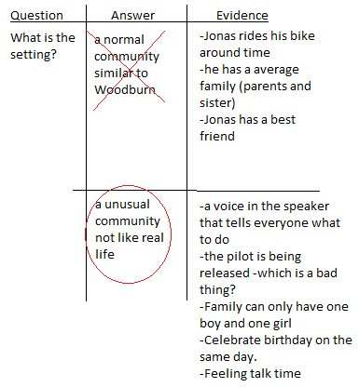

As you can see there are many things that show us that the community is normal and not normal. Keep this h-chart because we will be adding on to it as we read. Feel free to use this to add questions as you read.
Remember that, “Readers revise original ideas as the story develops by gathering evidence.”
Active Involvement:
Now it is your turn to revise your own idea. I will show you a short video and I want you to think about what the relationship between the main characters is like. I will pause every minute or so for you to answer this question and add evidence to what you think.

(https://www.youtube.com/watch?v=Mpj5SaGJyqA Here is a Pixar short movie called “Partly Cloudy” that has a surprising ending. Feel free to supplement it with a different clip or short story with a surprise ending. Make a new H-chart for this on the board and pause it every minute or so to answer the question: What is the relationship between the cloud and the stork like?)
Readers revise original ideas as the story develops by gathering evidence.
Link:
As you read your own book today, try to gather evidence either in your head or on stickies of how your ideas change throughout the book. We as readers need to revise original ideas as the story develops by gathering evidence.
Mid-Workshop Teaching Point:

Share:
(May want to share in book clubs the evidence they gathered)

Unit 6 Mini Lesson 4
Unit of Study: | Interpretation Text Sets
Goal: | Considering the implications of stories.
Teaching point (Kid language!): | Readers can find similar ideas across multiple texts by comparing text they have already read. (p.116-117 p. 126) 5.RML.6-4
Catchy phrase:
Text: | Number the Stars by Lois Lowry, The Giver by Lois Lowry
Chart(?): | Box & T-Chart (Similarities Lesson 4, Differences Lesson 5)
Standard: | 5.RL.1 Quote accurately from a text when explaining what the text says explicitly and when drawing inferences from the text.  5.RL.2 Determine a theme of a story, drama, or poem from details in the text, including how characters in a story or drama respond to challenges or how the speaker in a poem reflects upon a topic; summarize the text.

Mini Lesson: (7-10 minutes total)
Connection:
Yesterday, learned that, “Readers revise original ideas as the story develops by gathering evidence.” I really liked that we actually crossed out what we first thought about the community. That was powerful.
Today, we’re going to look for similarities across our current book, The Giver and Number the Stars, which were both written by the same author, Lois Lowry.
Readers can find similar ideas across multiple texts by comparing text they have already read
Teach:
Remember when we read Number of Stars, and Annemarie and Ellen were having fun racing home. It all seemed normal, until the German soldier stopped them and began to question them. A similar thing happened in The Giver, at the beginning Jonas appeared to live in a normal town, riding bikes with a plane flying overhead, but all of the sudden a voice came over the Speaker and ordered them to go inside.

I got the feeling in both books that (an unseen) someone is controlling their actions. I believe this is a similar idea that both these books have. It’s kind of like when my mom tells me to clean my room, and my dad orders me to take out the trash. Someone is in charge, and it’s not me.
(Create beginning of Box & T-Chart) (leave bottom blank for next lesson)
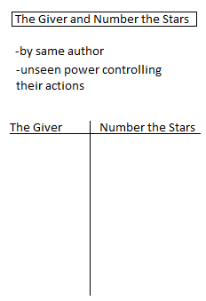

Readers can find similar ideas across multiple texts by comparing text they have already read
Active Involvement:
Now it is your turn to find stories that have similar ideas to The Giver. Can you think of any other book or even movies that start similarly to The Giver where it seems like it is the normal world and then weird things start happening that make you realize things are not what they seem?

(Think, Pair, Share. Possible answers: Hunger Games, Harry Potter, Gregor the Overlander, Ender’s Game, Toy Story, Where the Wild Things Liven encourage them to get creative and no answers are bad answers)

Are there any other ideas in the Giver that remind you of other books or movies? (Think, pair, share again)

This is important to remember as you read because good readers can find similar ideas across multiple texts by comparing text they have already read.
Link:
As you go out and read today in your book club book, I want to look for ideas that remind you of other stories you have read. Look for one good example of a connection to another story that you can share with your book club. Readers can find similar ideas across multiple texts by comparing text they have already read.
Mid-Workshop Teaching Point:

Share:
Get together with your book clubs and share your connection that you made with other stories to your books.

Unit 6 Mini Lesson 5
Unit of Study: | Interpretation Text Sets
Goal: | Themes may be the same across book, but they’re usually developed differently.
Teaching point (Kid language!): | Readers recognize differences in similar text by focusing on setting and how it affects the meaning. (p.119 p.126) 5.RML.6-5
Catchy phrase:
Text: | Number the Stars by Lois Lowry, The Giver by Lois Lowry
Chart(?): | Box & T-Chart (Similarities Lesson 4, Differences Lesson 5)
Standard: | 5.RL.1 Quote accurately from a text when explaining what the text says explicitly and when drawing inferences from the text.  5.RL.2 Determine a theme of a story, drama, or poem from details in the text, including how characters in a story or drama respond to challenges or how the speaker in a poem reflects upon a topic; summarize the text

Mini Lesson: (7-10 minutes total)
Connection:
Yesterday we looked at the similarities of the setting in our books The Giver and Number the Stars. Today, we’re going to focus more on the differences. Readers recognize differences in similar text by focusing on setting and how it affects the meaning
Teach:
As I’m thinking about the differences of these similar texts I now want to go back to my Box and T-Chart and add some. (Add a few ideas for differences seen in the example chart below)

(Point out the vocabulary word Utopian and how that means an ideal world, like in the Giver where there is no war. It would be good to bring up the opposite word: Dystopian futures which are very popular themes today in shows where there are zombie outbreaks and the world is threatened to be destroyed by natural disasters. Also, as you add how two books are different in how they obey the rules, talk about how it is okay to add more similarities above because that makes us think about how both books have strict punishments when rules are broken.)

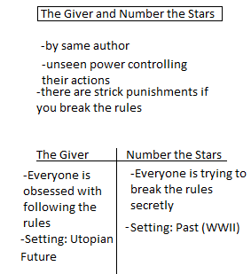

Readers recognize differences in similar text by focusing on setting and how it affects the meaning
Active Involvement:
Now it is your turn to think of differences between these two texts. How they different? I challenge you to think deeper than the obvious differences like one character is a boy and the other is a girl. Dig deep into the themes and ideas of the books. You make also come up with some more similarities and that is okay to share those too.

(Have students discuss with a partner. Teacher circulates the room and invites students with interesting differences to go up and write them on the chart)
Readers recognize differences in similar text by focusing on setting and how it affects the meaning
Link:
So, “Readers recognize differences in similar text by focusing on setting and how it affects the meaning.” As you continue reading today, pay close attention to the differences in the setting in your book with The Giver. Keep your stickies and a pencil on hand or your reading journal to jot down your ideas to share latter in your book clubs.
Mid-Workshop Teaching Point:

Share:
It’s time to share in your book clubs what you’ve discovered today about the differences in the setting of your book with The Giver.

Unit 6 Mini Lesson 6
Unit of Study: | Interpretation Text Sets
Goal: | Themes may be the same across book, but they’re usually developed differently.
Teaching point (Kid language!): | Readers develop systems to help them recall text by creating a graphic organizer to note similarities, differences and how it affects our ideas. (p.119 p. 126-127) 5.RML.6-6
Catchy phrase:
Text: | Number the Stars by Lois Lowry, The Giver by Lois Lowry
Chart(?): | Boxes and Bullets (will us in other lesson)
Standard: | 5.RL.1 Quote accurately from a text when explaining what the text says explicitly and when drawing inferences from the text.  5.RL.2 Determine a theme of a story, drama, or poem from details in the text, including how characters in a story or drama respond to challenges or how the speaker in a poem reflects upon a topic; summarize the text

Mini Lesson: (7-10 minutes total)
Connection:
Yesterday, we worked on, “Readers recognizing differences in similar text by focusing on setting and how it affects the meaning.” We finished our chart on the similarities and differences.
Now, let’s turn our focus on understanding that, “Readers develop systems to help them recall text by creating a graphic organizer to note similarities, differences and how it affects our ideas.” We’ve used graphic organizers all year long, and today we get a chance to use them to recall previous books we’ve read.
Teach:
Let me demonstrate one graphic organizer called boxes and bullets. (start yours by demonstrating with The Giver and Number of Start) (see example below)
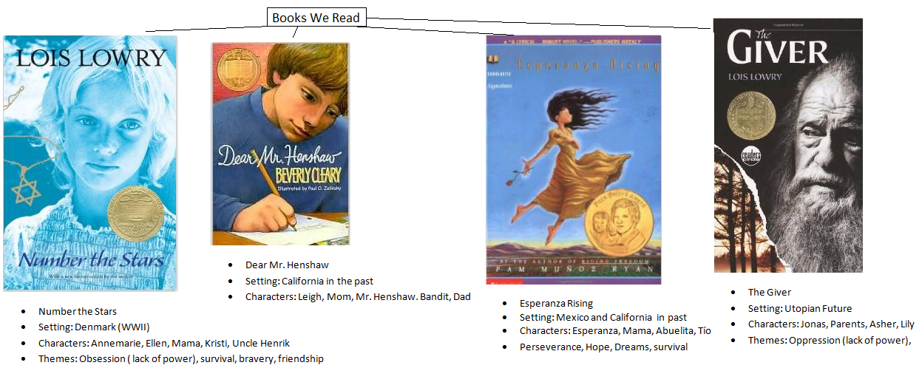

Readers develop systems to help them recall text by creating a graphic organizer to note similarities, differences and how it affects our ideas. Now it will be easier for us to compare all of the books we read and remember them.
Active Involvement:
Now it’s your turn to think about Esperanza Rising and Dear Mr. Henshaw and the information that we want to include, such as: Titles, Characters, Places, and Themes

(Think-Pair-Share)

Let’s add this to the graphic organizer. (As you share continue filling in the information)

Now that we have this visual, how does it affect our ideas about these books?

As you go through life remember that, “Readers develop systems to help them recall text by creating a graphic organizer to note similarities, differences and how it affects our ideas.”
Link:
So, now that we better understand that, “Readers develop systems to help them recall text by creating a graphic organizer to note similarities, differences and how it affects our ideas,” it is our turn to create one with the book club book you are reading now. As you read quickly jot down the book, characters, setting, and themes of your book to compare with your club during our sharing time. .
Mid-Workshop Teaching Point:

Share:
It’s now time to get into our book clubs and share the graphic organizer you did our your book.

Unit 6 Mini Lesson 7
Unit of Study: | Interpretation Text Sets
Goal: | Themes may be the same across book, but they’re usually developed differently.
Teaching point (Kid language!): | Readers analyze differences in characters by paying attention to character traits. (p.120 p. 127) 5.RML.6-7
Catchy phrase:
Text: | Number the Stars by Lois Lowry, The Giver by Lois Lowry
Chart(?): | Box & T-Chart
Standard: | 5.RL.1 Quote accurately from a text when explaining what the text says explicitly and when drawing inferences from the text.  5.RL.2 Determine a theme of a story, drama, or poem from details in the text, including how characters in a story or drama respond to challenges or how the speaker in a poem reflects upon a topic; summarize the text

Mini Lesson: (7-10 minutes total)
Connection:
Yesterday, we worked on graphic organizers. Our goal was to understand who “Readers develop systems to help them recall text by creating a graphic organizer to note similarities, differences and how it affects our ideas.”
Today we get to analyze differences in character by paying attention to character traits.

Teach:
In order to help us analyze the differences we’re going to use what we learned yesterday and put our ideas into a Box & T-Chart. (see example below)
Let’s analyze Jonas from The Giver with Annemarie from Number the Stars. When we do this let’s look at their Background, Relationships, Pressures, and Perspectives. I’m going to fill in part of it, for example their similarities and differences in their background and relationships, and later you’ll get a chance to do the pressures and perspectives.

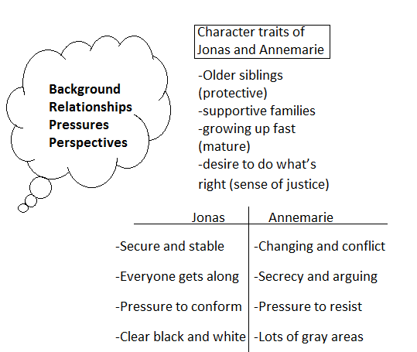
Readers analyze differences in characters by paying attention to character traits.
Active Involvement:
I want your help with this next part. I showed you how to compare and contrast the character traits of background and relationships. Now lets work on pressures together. Pressure means what forces are pushing against Annemarie and Jonas? How do they react to these pressures? (Think, pair, share and add these ideas to the chart)

How about perspectives? What perspective or what point of view does Annemarie have on the world? How about Jonas? (Think, pair, share, and write ideas on the chart)

Remember today and everyday, readers analyze differences in characters by paying attention to character traits.
Link:
Now it’s your turn to jump back into your books and today, pay close attention to the character traits we talked about today, but now apply them with your own characters in your books. Don’t forget that, “Readers analyze differences in characters by paying attention to character traits.”
Mid-Workshop Teaching Point:

Share:
(If you’ve had them practice this in their reading, meeting in book clubs for 5 minutes to discuss this would be powerful.)

Unit 6 Mini Lesson 8
Unit of Study: | Interpretation Text Sets
Goal: | Themes may be the same across book, but they’re usually developed differently.
Teaching point (Kid language!): | Readers learn from characters by noticing how characters respond to different challenges and apply what they learn to their own lives (p.120 p. 127) 5.RML.6-8
Catchy phrase:
Text: | The Giver by Lois Lowry
Chart(?):
Standard: | 5.RL.1 Quote accurately from a text when explaining what the text says explicitly and when drawing inferences from the text.  5.RL.2 Determine a theme of a story, drama, or poem from details in the text, including how characters in a story or drama respond to challenges or how the speaker in a poem reflects upon a topic; summarize the text

Mini Lesson: (7-10 minutes total)
Connection:
Lately we’ve been working on using graphic organizers and analyzing differences in character traits and themes.

Today we’re going to give the graphic organizers a break and focus on how, “Readers learn from characters by noticing how characters respond to different challenges and apply what they learn to their own lives.”
Teach:
There are lessons for life everywhere. Have you ever known someone you look up to and want to be like. They seem so wise or they handle problems so smoothly. You just want to hang around them and watch them. That is how I feel when I read about Jonas; I pay attention to how he faces challenges and I can actually learn from him that way.

For example, listen to how handles this situation. (Read p. 47 half way down to the end of p. 48) I am more like Asher alway nervous about what is going to happen next and really worrying if I am going to fail. But see how Jonas doesn't let him bother him because he has this internal confidence that everything will work out in the end. He knows worrying doesn't solve anything.

To go a step farther still; Jonas inspires me to worry less about tomorrow and to trust that it will work out. That is why readers learn from characters by noticing how characters respond to different challenges and apply what they learn to their own lives.
Active Involvement:
Now it’s your turn to try this. Think about your book you are reading. Pick a part in the book where a character has to respond to a challenge or problem. How does this character respond? How can you apply what you’ve learned in your own life?

(Think-Pair-Share)

Readers learn from characters by noticing how characters respond to different challenges and apply what they learn to their own lives.
Link:
As you go off to read think about the challenges your characters are facing and how they are responding, then apply it to yourself by asking; How does what I learned from (your character) make me change how I live my life? It’s true that, “Readers learn from characters by noticing how characters respond to different challenges and apply what they learn to their own lives.”
Mid-Workshop Teaching Point:

Share:

Unit 6 Mini Lesson 9
Unit of Study: | Interpretation Text Sets
Goal: | Themes may be the same across book, but they’re usually developed differently.
Teaching point (Kid language!): | Readers process the story by keeping track of what is happening and adding on new information. 5.RML.6-9
Catchy phrase:
Text: | The Giver by Lois Lowry
Chart(?): | H-Chart from lesson 3
Standard: | 5.RL.1 Quote accurately from a text when explaining what the text says explicitly and when drawing inferences from the text.  5.RL.2 Determine a theme of a story, drama, or poem from details in the text, including how characters in a story or drama respond to challenges or how the speaker in a poem reflects upon a topic; summarize the text

Mini Lesson: (7-10 minutes total)
Connection:
You all did a great job yesterday learning from how your characters respond to challenges. I sure now am more aware of how I can let chapters of books influence my life.
Today, let’s practice keeping track of our story.
Readers process the story by keeping track of what is happening and adding on new information.
Teach:
In order to understand or process the story better let’s pull out our chart from lesson 3 and add more details to it. First I’d like to add more evidence that the community is “unusual.” Let me add that it’s strange that at age 12 everyone gets assigned jobs at a special Ceremony.

Not only can we add new information, but we can also add questions, even though we don’t have the exact answer, or are unsure we know the answer. For example, in The Giver it always takes about “Release” So I’m going to add that as a question. I can also add some evidence to what I think the answer is even though I’m not quite sure yet. (Fill in on chart)
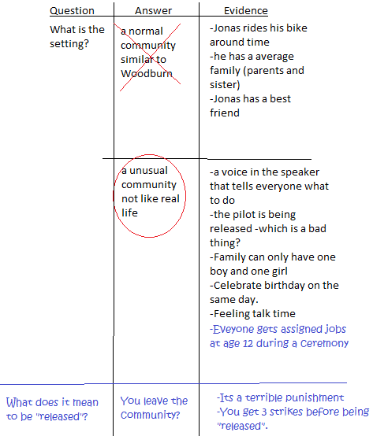
Readers process the story by keeping track of what is happening and adding on new information.
Active Involvement:
What else could we add to this H-chart? Do you have more evidence to add? Is there any other questions you thought of as we read that we should add to the H-chart? (Think, Pair, Share and add more to the chart)
Readers process the story by keeping track of what is happening and adding on new information.
Link: So today before you read your book club book, (add to your h-chart or) make an h-chart in your reading journal that you will keep and continue to add to as you read because expert readers process the story by keeping track of what is happening and adding on new information.
Mid-Workshop Teaching Point:

Share: (Have book clubs get together and share their H-chart)

Unit 6 Mini Lesson 10
Unit of Study: | Interpretation Text Sets
Goal: | Symbolism and literary devices and their relationship to the meanings and themes of stories.
Teaching point (Kid language!): | Readers understand deeper significances in their texts by thinking about objects that repeat. 5.RML.6-10
Catchy phrase:
Text: | Number the Stars by Lois Lowry
Chart(?): | H-Chart (continued)
Standard: | 5.RL.1 Quote accurately from a text when explaining what the text says explicitly and when drawing inferences from the text.  5.RL.2 Determine a theme of a story, drama, or poem from details in the text, including how characters in a story or drama respond to challenges or how the speaker in a poem reflects upon a topic; summarize the text

Mini Lesson: (7-10 minutes total)
Connection:
Yesterday, we spent our time working on, “Readers processing the story by keeping track of what is happening and adding on new information.” It’s very powerful to go back to what you have already done and add to it. Readers and writers do that all the time.
Today, as readers, we’re going to understand deeper significances in texts by thinking about objects that repeat.
Teach:
Often as we read and an object repeatedly comes up and often that object has a deeper significance. Let me show you an example and then we can see if we can find more.

In “Number the Stars,” Ellen wore a necklace, but it wasn’t just any necklace it was her special religious necklace of the Star of David that identified her as a Jew. Several times throughout this book the author refers to it. Remember the time when Annemarie and Ellen were sleeping and the Nazi Soldiers came into their bedroom, and Annemarie had to rip the necklace off Ellen. At the end in her hand you could see the imprint of the Star of David, because she’d been holding onto it so tight. I believe this necklace is an object that we see often in this book, which has a deeper significance. I believe the deeper significance is that it is Ellen is trying to hold on to her believes that she has been raised with her whole life. Everytime she touches the necklace makes me think that she is trying to stay true to what she believes. Then Annemarie continues to hold on to it throughout the book and Ellen continues to ask about it.

I also believe that as Annemarie is marked with the Star of David from holding on to it so tight when the soldiers were in her room that it symbolizes how she desires to hold onto her own beliefs and her best friend.
In many books there are objects that repeat, when you notice an object repeating it is a signal to you that you should stop and reflect on the deeper significance of that object. Remember, “Readers understand deeper significances in their texts by thinking about objects that repeat.”
Active Involvement:
Now it’s your turn think about repeating objects in The Giver. Ask yourself, Which objects do I see that repeat several times? Think for about 30 seconds and then share with your partner.

As I was eavesdropping I heard these objects. I’m going to add to our H-Chart.
Why does the author keep bringing up: (objects: Bike, River, Gabriel, Speaker, Sled, Color Red, Jonas eye color) (pick one or two to add to the chart)

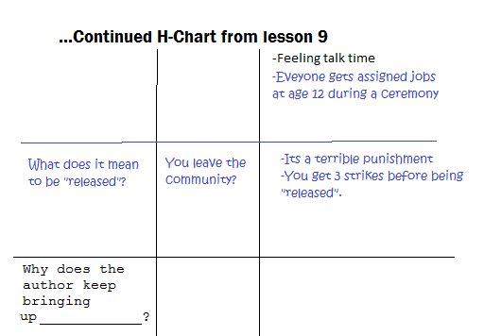

What do you think the meaning of these objects might be? (you may want to reference the notes below about the symbolism in the Giver).
Readers understand deeper significances in their texts by thinking about objects that repeat.
Link:
Now that we’ve worked a bit on looking for repeated objects and their deeper significance, I’d like you pay close attention to objects that repeat in your own book club books and think if they may have deeper meaning. Remember, “Readers understand deeper significances in their texts by thinking about objects that repeat.”
Mid-Workshop Teaching Point:

Share:

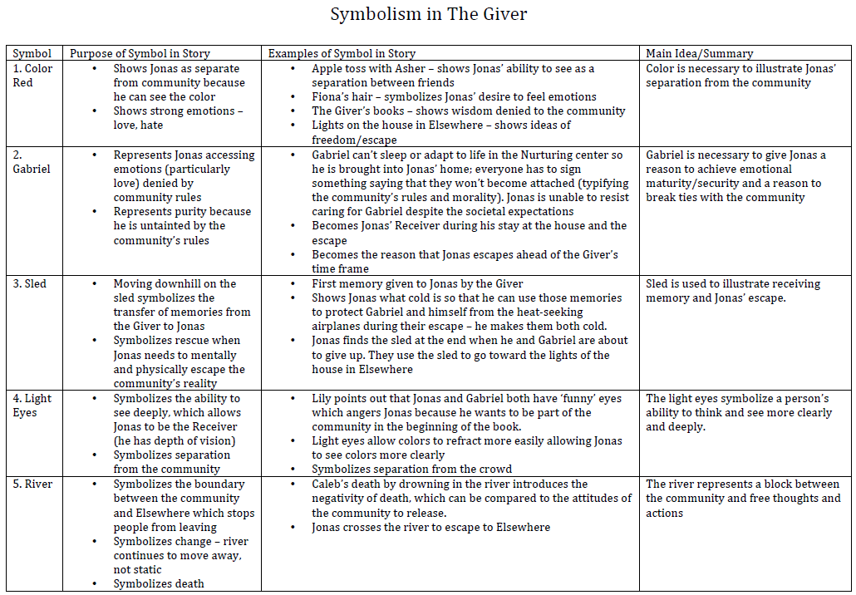

Unit 6 Mini Lesson 11
Unit of Study: | Interpretation Text Sets
Goal: | Symbolism and literary devices and their relationship to the meanings and themes of stories.
Teaching point (Kid language!): | Readers add to their symbolic understanding of the text by thinking about the potential meanings of titles. 5.RML.6-11
Catchy phrase:
Text: | Number the Stars by Lois Lowry, The Giver by Lois Lowry, Dear Mr. Henshaw, Esperanza Rising
Chart(?): | Display chart from lesson 6
Standard: | 5.RL.1 Quote accurately from a text when explaining what the text says explicitly and when drawing inferences from the text.  5.RL.2 Determine a theme of a story, drama, or poem from details in the text, including how characters in a story or drama respond to challenges or how the speaker in a poem reflects upon a topic; summarize the text  5.RL.4 Determine the meaning of words and phrases as they are used in a text, including figurative language such as metaphors and similes.  5.RL.9 Compare and contrast stories in the same genre (e.g., mysteries and adventure stories) on their approaches to similar themes and topics.

Mini Lesson: (7-10 minutes total)
Connection:
Today, we’re going to continue with looking for repeated objects and uncovering their deeper meaning. To take this work even further we’re going to look for symbolism, because, “Readers add to their symbolic understanding of the text by thinking about the potential meanings of titles.
Teach:
(display chart from lesson 6)
When you pick up a book what is the first thing you do? For me, I read the title and wonder: “What does this title mean?” That is what I did when I first read “Number the Stars” and that is what I am doing now as I read “The Giver.”

Why did Lois Lowry choose those names for her books. I don’t think we have read enough of The Giver to figure out the name. Sometimes authors do not reveal the significance of the title to the very end; its like a little mystery they want you to solve.

In Number the Stars, the true significance was not revealed until p 86. But you could guess at the meaning early on because what is that goal thing on the cover? Its the Star of David, Ellen’s necklace. It is a star and the book is called “Number the Stars” so that must be significant.

On p. 86 at the climax of the book where all of Ellen’s family along with other jews are waiting to get on a boat to escape the Nazi clutches, they read this Psalm (Read italicized passage)

Did you hear it. It said “he who numbers the stars one by one”. Who is “he”? The God of the Jews. And who do you think the stars represent? The Jews. Now we understand Number the Stars means God numbered the Jews, gathered the Jews, and will save the Jews.

Readers add to their symbolic understanding of the text by thinking about the potential meanings of titles.
Active Involvement:
Now it’s your turn to analyze the titles of these other books, and think about the potential meaning of the titles. (Think-Pair-Share)

(have one student share about what the think the meaning of Esperanza Rising is. Make sure you pick one who you heard has it)

Good, let’s jot this down on our chart . The meaning of the title is: rising above the challenges. Esperanza mean hope in spanish.

(You can add to Dear Mr. Henshaw and The Giver is you have time)

Readers add to their symbolic understanding of the text by thinking about the potential meanings of titles.
Link:
Now that you’ve practice remember that as you read look for potential meanings of the title, often their symbolic meaning will give you further understanding and enjoyment in your book. Later in book clubs I’d like you to discuss what you think your title means, so you may want to jot down a note or two on a sticky. Readers add to their symbolic understanding of the text by thinking about the potential meanings of titles.
Mid-Workshop Teaching Point:

Share:
Time to get in our book clubs and share what you think the meaning of your title is, and how that helps you understand your book better.

Unit 6 Mini Lesson 12
Unit of Study: | Interpretation Text Sets
Goal: | Symbolism and literary devices and their relationship to the meanings and themes of stories.
Teaching point (Kid language!): | Readers understand that details matter by figuring out the possible meanings with perplexing or unexplained details. 5.RML.6-12
Catchy phrase: | “perplexing details”
Text: | The Giver by Lois Lowry
Chart(?): | H-Chart (continued)
Standard: | 5.RL.1 Quote accurately from a text when explaining what the text says explicitly and when drawing inferences from the text.  5.RL.2 Determine a theme of a story, drama, or poem from details in the text, including how characters in a story or drama respond to challenges or how the speaker in a poem reflects upon a topic; summarize the text

Mini Lesson: (7-10 minutes total)
Connection:
Yesterday we worked on analyzing the titles of the books and looking for deeper significance. In your book clubs you had the opportunity to begin to unfold what you think your title means. Today, we're going to understand that details matter by figuring out the possible meanings with perplexing or unexplained details.
Teach:
Often as we read we come across unexplained or even confusing/perplexing details. One of the details that I see several times in The Giver is Jona’s eye color. Several times in the book his eyes are mentioned because they are clear, unlike most of the other people in his community. He even had a special connection with Gabriel the baby, because both had clear eyes. This made me wonder, I was even a little perplexed because I didn’t understand how this detail was important. I figured it must be important because it repeated several time, but I couldn’t wrap my head around the idea of why. And it is okay to be perplexed or puzzled by a detail. Sometimes you just have to be okay with that uncertainty and move on trusting that it will make sense later.

Then I started to think deeper and realize that this separates him from the rest of the community. It starts to show that there is something different about him, and I believe that leads him to becoming use to being different, which helps him when he receives his call to be the giver. As I continue reading I may gather more evidence to support my thoughts, or I may realize that my thinking wasn’t correct, but I’m willing to adjust my thinking as I gather more evidence. Often authors will intentionally put in details that are difficult and confusing, to help the reader get more involved and want to figure things out. So, don’t get frustrated, use this as a challenge to figure out the possible meanings of the perplexing details.

Readers understand that details matter by figuring out the possible meanings with perplexing or unexplained details
Active Involvement:
You may find perplexing or unexplained details anywhere in life. Lets look at this clip and tell me what perplexing details you can find in it. Why are the perplexing?

( This is a Pixar short film called “La Luna” or feel free to use another clip that has perplexing details https://www.youtube.com/watch?v=Mpj5SaGJyqA Pause every minute or so and talk about the perplexing details and possible meanings. Give them private think time, partner talk time, and a little share time. Write down questions as you go on an H-chart)

As the story progressed some of those perplexing details got explained but not all of them. Sometimes authors do not explain everything on purpose. Why do you think they do that? (Think, pair, share)

Readers understand that details matter by figuring out the possible meanings with perplexing or unexplained details
Link:
As you read in your book club book today, I would like you to keep your eyes open for perplexing details and write down questions about them in your H-chart. Then when we meet as book clubs, share these details and have a discussion about what they might mean. Readers understand that details matter by figuring out the possible meanings with perplexing or unexplained details
Mid-Workshop Teaching Point:

Share:
(In the last 10 minutes have book clubs meet and discuss the perplexing details they found. Circulate around and remind students of the Last Word protocol.)

Unit 6 Mini Lesson 13
Unit of Study: | Interpretation Text Sets
Goal: | Symbolism and literary devices and their relationship to the meanings and themes of stories.
Teaching point (Kid language!): | Readers better understand the significance of repetition by thinking, reading and writing about its potential meanings. (p. 122p. 128) 5.RML.6-13
Catchy phrase: | Find the Easter eggs.
Text: | The Giver by Lois Lowry
Chart(?): | H-chart (continued)
Standard: | 5.RL.1 Quote accurately from a text when explaining what the text says explicitly and when drawing inferences from the text.  5.RL.2 Determine a theme of a story, drama, or poem from details in the text, including how characters in a story or drama respond to challenges or how the speaker in a poem reflects upon a topic; summarize the text

Mini Lesson: (7-10 minutes total)
Connection:
Yesterday we talked about perplexing details and every reader will come across details that won't make any sense at the time. It may feel uncomfortable but we need to just accept that it doesn't make sense and that the author will explain before they are finished with the book.

Today we are going to talk more about the literary device, repetition and how the author uses this give hidden meaning about the book if we are willing to think, read, and write about it.
Teach:
How many of you play video games? Have you ever found an Easter Egg in one? I do not mean a literal Easter Egg but that is what they call hidden messages that game writers put in the game. Often you find them by looking for perplexing details or repetition like a corner of a room where there is actually a hidden hallway.

Writers of books put hidden messages in their books as well by using repetition but sometimes the meaning of the repetition is hard to decipher. It involves brain power to unlock the meaning. When I come across repetition first I reread it, then I will put down the book and just think about it, and then I will write it down in my H-chart what I am thinking.

For example in the Giver: (Put p. 50-51 on the doc cam so everyone can see the text. Read it aloud to the class)
Do you notice that they use a ton of numbers here and everytime they use them they are always written out and capitalized. When I first saw this I thought it was a typo because you don't capitalize numbers but then it kept happening so I realized that his repetition was significant. I am going to reread it again more slowly while thinking about the hidden message of the numbers (Read again)

Now I am going to write down in my H-chart some of the examples where these numbers are used (see chart).
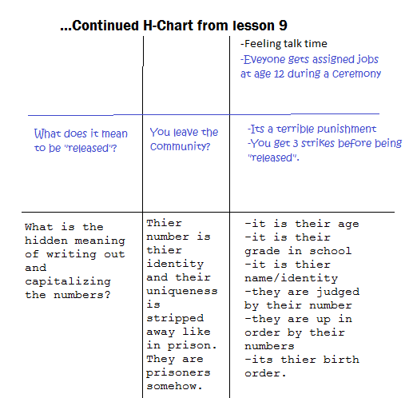

As I look at this and think about this I realize that these numbers represent their identity and even can be used as their name. I can think of 2 places where people’s numbers are their names: concentration camps during the holocaust and in prisons. In both places they do this to take away a person’s individual identity. I think the hidden meaning of this is the author is trying to tell you that Jonas isn't as free as he seems. He is a prisoner.
Active Involvement:
Now it is your turn to find the “Easter Egg” or the hidden messages in repeated details. I am going to so you a short film and pause it every minute or so for you to practice thinking about and writing down repeating detail. Lets see if you can crack the message:

(https://www.youtube.com/watch?v=HSxJkKiHXbw This is a link to a short Disney film called Paperman where there are significance in the pieces of paper and the wind. Feel free to substitute this with a different clip with symbolism.)
Now share with a partner the repetition that you found in this film. (Partner share and write down repeating items: wind, paper, paper airplanes exc. There are no wrong answers and encourage students to think outside the box)

What do you think these repeating items symbolize?
Link: As you go out to read your book club book I want you to remember: Readers better understand the significance of repetition by thinking, reading and writing about its potential meanings.

I want you to practice this and then you will share out the “Easter eggs” or secret messages that the author was giving through repetition.
Mid-Workshop Teaching Point:

Share:
(Have book clubs get together and discuss the hidden meanings the found.)

Unit 6 Mini Lesson 14
Unit of Study: | Interpretation Text Sets
Goal: | Symbolism and literary devices and their relationship to the meanings and themes of stories.
Teaching point (Kid language!): | Readers find deeper meanings in text by analyzing characters’ perspectives and points of view. (p.123 p. 128) 5.RML.6-14
Catchy phrase:
Text: | Number the Stars by Lois Lowry, The Giver by Lois Lowry
Chart(?):
Standard: | 5.RL.1 Quote accurately from a text when explaining what the text says explicitly and when drawing inferences from the text.  5.RL.2 Determine a theme of a story, drama, or poem from details in the text, including how characters in a story or drama respond to challenges or how the speaker in a poem reflects upon a topic; summarize the text

Mini Lesson: (7-10 minutes total)
Connection:
We have talked about finding the hidden meaning or the “Easter egg” so far in perplexing details, and in repetition. Today I am going to show you how to find the “Easter egg” in characters’ point of view.

Readers find deeper meanings in text by analyzing characters’ perspectives and points of view.
Teach:
I am going to read a passage to you from the Giver and I want you to first think about being in this scene as if you were Jonas, standing in his shoes, and looking through his eyes. (Read p. 78)

What hidden meanings or Easter eggs are hidden in his perspective? I see that he does not understand anything about the world outside of his community or the idea of history. Since he was educated the same way as everyone else in the community, it makes me realize that no one understands these concepts. Why are they keeping them secret? Who is keeping them secret and why?

Now I am going to read it another time and this time I want you to put yourself in the shoes of the Receiver (Read passage again.)

What hidden meaning is in the Receiver's perspective? I feel loneliness and tiredness when I put myself in his shoes. I see that he has much power because he “shapes the future”. He must think that everyone else is so naive and only he is smart enough or wise enough to make important decisions. He has the power to break rules, turn off the speaker, and lie. He is above the law which makes him dangerous.

Readers find deeper meanings in text by analyzing characters’ perspectives and points of view.
Active Involvement:
Readers find deeper meanings in text by analyzing characters’ perspectives and points of view. We’re going to watch a short film that will help us understand point of view. When we are done you’re going to talk with your partner about how point of view changes.

(Short film “Alma”. Or substitute it with another short story where the point of view changes to reveal new information https://www.youtube.com/watch?v=irbFBgI0jhM)

Talk with your partner about how the point of view changed throughout the film, and what details now make sense. (Think-Pair-Share)
Link:
Today and everyday as you read, take into consideration the characters’ perspectives and points of view and how analyzing those things helps you find deeper meaning in the text.
Mid-Workshop Teaching Point:

Share:

