Unit 5 Table of Contents
Historical Fiction

Section | Page #
- Unit Goals and Standards | 3-4
- Unit 5 at a Glance | 5-6
- English/Spanish/Russian Monthly Planner | 7-8
- Assessment Checklist

Lesson | Lesson Title | Page #
Lesson 1 | Readers get to know the setting by paying attention to what it looks like and what it feels like. | 9-10
Lesson 2 | Readers support each other in their book clubs by listening and building on each other’s comments. | 11-14
Lesson 3 | Readers keep track of all the important details by creating a mental bulletin board. | 15-16
Lesson 4 | Readers make sense of what is happening in the story by paying attention to shifts in time. | 17-18
Lesson 5 | Readers understand characters by noticing how personal timelines connect to the historical timeline.  Los buenos lectores entienden a los personajes cuando siguen la línea cronológica del personaje y la línea cronológica histórica cuando leen ficción histórica. | 19-21
Lesson 6 | Readers understand the decisions characters make by recognizing that their behavior is influenced by what is happening around them. | 22-23
Lesson 7 | Readers know that when the story slows down the author is going to tell you something important so paying attention to the details in the story is key. | 24-25
Lesson 8 | Readers are authors of their own reading by bringing their own history to the book. | 26-27
Lesson 9 | Readers grow big ideas by pausing and pondering on pertinent passages. | 28-29
Lesson 10 | Readers support their big ideas by being alert to small details. | 30-31
Lesson 11 | Readers fine tune their interpretations of the big ideas by noticing the contrasts and contradictions | 32-34
Lesson 12 | Readers are open to revising their big ideas by listening to others’ ideas. | 35-37
Lesson 13 | Readers think critically while reading by considering the different points of view of all the characters. | 38-39
Lesson 14 | Readers revise their big ideas about characters by considering new understandings around points of view. | 40-41
Lesson 15 | Readers find huge meanings in book by investigating who has power and in what form and how it shifts. | 42-44
Lesson 16 | Readers spark new ideas by reading non-fiction about the same time period. | 45-49
Lesson 17 | Readers notice common themes across texts by comparing and contrasting people, places, events and ideas. | 50-51
Lesson 18 | Readers express big ideas by making allusions to one character by basing it off another person. | 52-53
Lesson 19 | Readers adapt their world view by learning from the choices the characters make. | 54-55

Grade 5 Reading Unit 5
Unit of Study Planning Template
Unit: Historical Fiction Book Clubs

Goals:  (These should align with Essential Questions. Each goal is developed in the following planning pages- one per goal.) | - Tackling complex text in the company of friends  - Interpreting complex texts  - Becoming more complex because we read

Essential Questions:
(These should be aligned with Goals.)

Standards: | RL.5.1 Quote accurately from a text when explaining what the text says explicitly and when drawing inferences from the text.  RL.5.2 Determine a theme of a story, drama, or poem from details in the text, including how characters in a story or drama respond to challenges or how the speaker in a poem reflects upon a topic; summarize the text.  RL.5.3 Compare and contrast two or more characters, settings, or events in a story or drama, drawing on specific details in the text (e.g., how characters interact).  RL.5.5 Explain how a series of chapters, scenes, or stanzas fits together to provide the overall structure of a particular story, drama, or poem.  RL.5.6 Describe how a narrator’s or speaker’s point of view influences how events are described.  RL.5.9 Compare and contrast stories in the same genre (e.g., mysteries and adventure stories) on their approaches to similar themes and topics.  RL.5.10 By the end of the year, read and comprehend literature, including stories, dramas, and poetry, at the high end of the grades 4–5 text complexity band independently and proficiently.  SL.5.1 Engage effectively in a range of collaborative discussions (one-on-one, in groups, and teacher-led) with diverse partners on grade 5 topics and texts, building on others’ ideas and expressing their own clearly.  - Come to discussions prepared, having read or studied required material; explicitly draw on that preparation and other information known about the topic to explore ideas under discussion.  - Follow agreed-upon rules for discussions and carry out assigned roles.  - Pose and respond to specific questions by making comments that contribute to the discussion and elaborate on the remarks of others.  - Review the key ideas expressed and draw conclusions in light of information and knowledge gained from the discussions.  SL.5.3 Summarize the points a speaker makes and explain how each claim is supported by reasons and evidence.

Key Vocabulary: | Perspective, point of view, allusion, historical fiction, non-fiction, compare, contrast, alert, shifts in time, setting, timeline, influenced, power, ponder, pertinent, revise, theme

Anchor Texts: | Number the Stars, Pink and Say

Other Resources:

Assessment:  (Including CCSS performance task.) | FORMATIVE  - Assessment checklist  - Anecdotal notes  - Conferring notes  - Running records | SUMMATIVE  - Reading club sharing information with class

Unit of Study At A Glance Planner

UNIT 5 Historical Fiction Book Clubs
GOAL:  Tackling complex text in the company of friends | GOAL:  Interpreting complex texts | GOAL:  Becoming more complex because we read
MINILESSONS: | MINILESSONS: | MINILESSONS:
- Readers get to know the setting by paying attention to what it looks like and what it feels like. 5.RML.5-1 (P. 86 & P. 96)  - Readers support each other in their book clubs by listening and building on each other’s comments. 5.RML.5-2 (P. 87 & 96)  - Readers keep track of all the important details by creating a mental bulletin board. 5.RML.5-3 (P. 87 & 96)  - Readers make sense of what is happening in the story by paying attention to shifts in time. 5.RML.5-4 (P. 87. & P. 96)  - Readers understand characters by noticing how personal timeline connects to a historical timeline. 5.RML.5-5 (P. 87-88 & P.96)  - Readers understand the decisions characters make by recognizing that their behavior is influenced by what is happening around them. 5.RML.5-6 (P. 88 & 97.)  - Readers know that when the story slows down the author is going to tell you something important so paying attention to the details in the story is key. 5.RML.5-7 (P. 86 & 97) | - Readers are authors of their own reading by bringing their own history to the book. 5.RML.5-8 (P.89 &97)  - Readers grow big ideas by pausing and pondering on pertinent passages. 5.RML.5-9 (P.89 & P. 97)  - Readers support their big ideas by being alert to small details. 5.RML.5-10 (P. 90 & 97)  - Readers fine tune their interpretations of the big ideas by noticing the contrasts and contradictions. 5.RML.5-11 (P. 90 & 97)  - Readers are open to revising their big ideas by listening to others’ ideas. 5.RML.5-12 (P.90 & 98) | - Readers think critically while reading by considering the different points of view of all the characters. 5.RML.5-13 (P. 91 & 98)  - Readers revise their big ideas about characters by considering new understandings around points of view. 5.RML.5-14 (P. 98)  - Readers find huge meanings in book by investigating who has power and in what form and how it shifts. 5.RML.5-15 (P. 91 & 98)  - Readers spark new ideas by reading non-fiction about the same time period. 5.RML.5-16 (P. 91 & 98)  - Readers notice common themes across texts by comparing and contrasting people, places, events and ideas. 5.RML.5-17 (P. 91,92, & 98, 99)  - Readers express big ideas by making allusions to one character by basing it off another person. 5.RML.5-18 (P. 92 & 99)  - Readers adapt their world view by learning from the choices the characters make. 5.RML.5-19 (P. 92 & 99)

WORKSHOP CALENDAR FOR: | Grade 5 Reading Unit 5 | Date: Mar. 1 - Apr. 11
Unit of Study: Unit 5 | Historical Fiction Book Clubs

MONDAY | TUESDAY | WEDNESDAY | THURSDAY | FRIDAY
1
Readers get to know the setting by paying attention to what it looks like and what it feels like.
5.RML.5-1
4  Readers support each other in their book clubs by listening and building on each other’s comments. 5.RML.5-2 | 5  Readers keep track of all the important details by creating a mental bulletin board. 5.RML.5-3 | 6  Readers make sense of what is happening in the story by paying attention to shifts in time. 5.RML.5-4 | 7  Readers understand characters by noticing how personal timeline connects to a historical timeline. 5.RML.5-5 | 8  Readers understand the decisions characters make by recognizing that their behavior is influenced by what is happening around them. 5.RML.5-6
11  Readers know that when the story slows down the author is going to tell you something important so paying attention to the details in the story is key. 5.RML.5-7 | 12  Mini Lesson Choice Day | 13  Readers are authors of their own reading by bringing their own history to the book. 5.RML.5-8 | 14  Readers grow big ideas by pausing and pondering on pertinent passages. 5.RML.5-9 | 15  Readers support their big ideas by being alert to small details. 5.RML.5-10
18  Readers fine tune their interpretations of the big ideas by noticing the contrasts and contradictions. 5.RML.5-11 | 19  Readers are open to revising their big ideas by listening to others’ ideas. 5.RML.5-12 | 20  Conferences | 21  Conferences | 22  No School
Apr 1  Readers think critically while reading by considering the different points of view of all the characters. 5.RML.5-13 | 2  Readers revise their big ideas about characters by considering new understandings around points of view. 5.RML.5-14 | 3  Readers find huge meanings in book by investigating who has power and in what form and how it shifts. 5.RML.5-15 | 4  Mini Lesson Choice Day | 5  Readers spark new ideas by reading non-fiction about the same time period. 5.RML.5-16
8  Work Day | 9  Readers notice common themes across texts by comparing and contrasting people, places, events and ideas. 5.RML.5-17 | 10  Readers express big ideas by making allusions to one character by basing it off another person. 5.RML.5-18 | 11  Readers adapt their world view by learning from the choices the characters make. 5.RML.5-19 | 12

Unit 5 Mini Lesson 1
Unit of Study: | Historical Fiction
Goal: | Tackling Complex Texts in the Company of Friends
Teaching point: | Readers get to know the setting by paying attention to what it looks like and what it feels like.
Catchy phrase: (Kid language!) | Physical details create an emotional atmosphere.
Text: | Number the Stars
Chart(?):
Standard: | RL.5.1 Quote accurately from a text when explaining what the text says explicitly and when drawing inferences from the text.  RL.5.2 Determine a theme of a story, drama, or poem from details in the text, including how characters in a story or drama respond to challenges or how the speaker in a poem reflects upon a topic; summarize the text.

Mini Lesson: (7-10 minutes total)
Connection:
(Before the start of this lesson, set up students into book clubs using historical fiction book sets.) (If your students don’t know what Historical Fiction is, you may want to teach that prior to starting).
Readers here’s the thing, all of us already know what a setting is in a story. It’s the time and place where the story or the scene happens.
Today I want to teach you that in historical fiction, the setting will inevitably be unfamiliar to us because it happened in the past before you were born. We have to really pay attention not just to what the place looks like, but also what it feels like. Physical details create an emotional atmosphere. Readers get to know the setting by paying attention to what it looks like and what it feels like.
Teach:
(Project this passage on the board under the doc cam: the last paragraph on page 1 and the first 2 paragraphs on page 2)
Watch me as I look for clues in the setting to tell me the emotional atmosphere of the book is like. (Read aloud the passage with animation and cheerfulness)
I can tell the setting is of two a sidewalk in the city of Copenhagen on a street called Osterbrogade; hmmm, I am not feeling much emotion yet because I have never been there. Then there was an old woman and a mother out with her baby; they would not be on the street if it wasn’t safe so I feel like this is a safe place. There are also little shops and cafes; I love shopping and coffee so this makes me feel happy. I would call this a safe and cheerful place … so far.
Now let me introduce a sentence frame that will help you make a statement about the setting.
(Write on the board: In the story, there is _____,therefore this makes me feel ______.)
I could say, “In this story, there is cafes, small shops, old women and mothers with babies, and children running races in the streets, therefore this makes me feel like this is a cheerful and safe place. This is a great example of physical details creating an emotional atmosphere.
Remember, readers get to know the setting by paying attention to what it looks like and what it feels like.
Active Involvement:
(Now project this passage: Start halfway down pg. 2 at the word “Halt?” to the bottom of the page.)
Now it is your turn. Lets read this passage together and then I want you to turn and talk to your partner about the emotional atmosphere of this setting. (Read the passage to the students) Now turn and talk to you partner about the physical details and what kind of emotional atmosphere they create. I want to hear students using the sentence frame. Remember, readers get to know the setting by paying attention to what it looks like and what it feels like.
(Wander around listening to students conversations. After a couple minutes, ask several students to share how the emotional atmosphere has changed.)
Link:
So today when you start reading the first few pages of your new book club book, be aware of the emotional atmosphere. Remember, readers get to know the setting by paying attention to what it looks like and what it feels like.
Mid-Workshop Teaching Point:
Share: In the last 10 minutes of class, let students get together into their new book clubs to discuss the emotional atmosphere of the setting. Have each group work together to write down a sentence from the sentence frame describing their setting. Then each group can share their sentence with the rest of the class by choral reading it together.

Unit 5 Mini Lesson 2

Unit of Study: | Historical Fiction Book Clubs
Goal: | Tackling complex text in the company of friends
Teaching point (Kid language!): | Readers support each other in their book clubs by listening and building on each other’s comments. 5.RML.5-2 (P. 87 & 96)
Catchy Phrase:
Text: | {have them sit in book clubs)
Chart:
Standard: | SL.5.1 Engage effectively in a range of collaborative discussions (one-on-one, in groups, and teacher-led) with diverse partners on grade 5 topics and texts, building on others’ ideas and expressing their own clearly.

Mini Lesson: (7-10 minutes total)
Connection: (1-2 min)
Yesterday, we learned that, “Readers get to know the setting by paying attention to what it looks like and what it feels like.”

Today, we’re going to learn how to support each other in our book clubs by listening and building on each other’s comments. In order to build on what each other say, we first need to be able to listen to understand each other.
Teach: (4-6 min)
When we have a class discussion, do you notice that there are some students who love to talk and others who are very quiet and never talk. Often those who never talk have really important insights that we want to hear. It is important for readers support each other in their book clubs by listening and building on each other’s comments.

One way to do this is to set up protocols or rules on talking. (It’s important to set up protocols for the book clubs to be successful. Here are a few suggestions: Talking Sticks, Talking Chips, Last word, etc. Here, we are going to use Last word and you can see the detailed protocol below, but feel free to supplement your own protocol.)
We are going to practice by doing a fishbowl watching a the protocol being practiced. (You will have wanted to pull 2-3 students aside ahead of time to teach them the Last Word protocol) Students part of the circle, you are the fishbowl which means you are silent. As you want you will be thinking of this question: What are the rules of this “The Final Word” and we will talk when we are done. Now, the book club sits in a circle in the middle and I am going to start by reading a passage I liked: “It is at the bottom of p. 2 ‘There were two of them. That meant two helmets, two sets of cold eyes glaring at her, and four tall shiny boots planted firmly on the sidewalk, blocking her path to home.’”

(Then let all of the students in your mock book club comment on that passage. When you get the final word, you may say something about how creative the writer was in writing by “showing and not telling”)

(Let the one or two others in your book club share their passages and repeat the protocol) Now fishbowl, what did you notice? What do you think were the rules of the “Final Word”.

Today, I’m going to 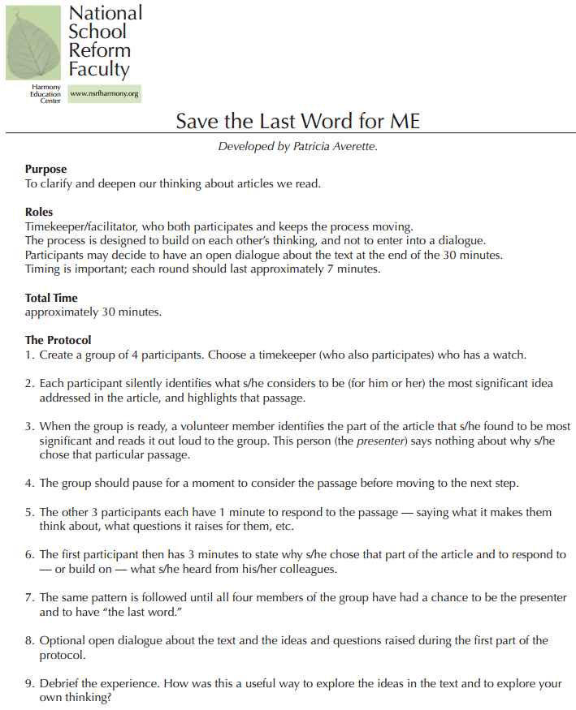
Active Involvement: (3-5 min)
Now you’re going to get a chance to practice this in your book clubs. Each of you will have 1 minute to pick an important of the book that you’ve already read. You may already have a sticky note of an important part, then you will use this Last Word protocol to talk about your book.

(Get in your groups and practice this protocol: teachers look for groups that are using it well. You may need to do mini-lessons with groups who are struggling).

(You may want to debrief how it went, or you want to stagger you groups to that you can support them as needed with using the protocol).

Remember: Readers support each other in their book clubs by listening and building on each other’s comments
Link: (1 min)
It’s your turn to put this in action. Remember that, “ Readers support each other in their book clubs by listening and building on each other’s comments.” When we really listen to each other, ideas pop in our heads that allow us to build on what other’s are saying. This is a great way to enjoy your book at a different level.
Mid-Workshop Teaching Point:
Share:

Unit 5 Mini Lesson 3

Unit of Study: | Historical Fiction Book Clubs
Goal: | Tackling complex text in the company of friends
Teaching point (Kid language!): | Readers keep track of all the important details by creating a mental bulletin board.
Catchy Phrase:
Text:
Chart: | Web
Standard: | RL.5.1 Quote accurately from a text (clip) when explaining what the text says explicitly and when drawing inferences from the text.

Mini Lesson: (7-10 minutes total)
Connection: (1-2 min)
Last time we meet we worked on Readers supporting each other in their book clubs by listening and building on each other’s comments. We even practice the Last Word protocol.

Today we’re going to watch a short clip on the movie Mulan. The reason we’re going to watch this is to learn and practice that, “Readers keep track of all the important details by creating a mental bulletin board.”
Teach: (4-6 min)
I’m going to start this clip, and as I do I’m going to attempt to keep track of all the important details by creating a web, to show you what my mental bulletin board looks like in my head.
(Show the first half of Mulan intro to 1:30 and then pause --youtube “Honor to Us All” https://www.youtube.com/watch?v=ZnUEDaeoF0Q )

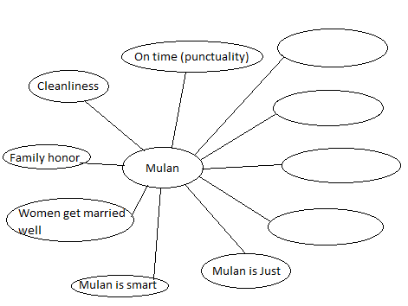

Even though it may not be easy, Readers keep track of all the important details by creating a mental bulletin board.
Active Involvement: (3-5 min)
Now it’s your turn to create your own mental bulletin board as we watch the second half of this Mulan clip. (Show the rest of the clip)

Think about all of the important details that you used in your mental bulletin board. Talk with your partner about what details you included, and why you think they were important. (1-2 min)
As I was eavesdropping I heard (include some details you overheard. Here are some examples you might here: Luckiness, Talk to ancestors, Matchmaker, Perfect porcelain doll, Everyone looks the same – not unique)
“Readers keep track of all the important details by creating a mental bulletin board”.
Link: (1 min)
As you continue to dive into your reading of Historical Fiction. Remember that Readers keep track of all the important details by creating a mental bulletin board.
Mid-Workshop Teaching Point:
Share:

Unit 5 Mini Lesson 4

Unit of Study: | Historical Fiction Book Clubs
Goal: | Tackling complex text in the company of friends
Teaching point (Kid language!): | Readers make sense of what is happening in the story by paying attention to shifts in time.
Catchy Phrase:
Text: | Number the Stars by Lois Lowry
Chart:
Standard: | RL.5.5 Explain how a series of chapters, scenes, or stanzas fits together to provide the overall structure of a particular story, drama, or poem.

Mini Lesson: (7-10 minutes total)
Connection: (1-2 min)
Yesterday we practiced putting important information on our “mental bulletin boards” to help us keep up with the story.
As we are becoming better readers, the books we are reading are becoming more complex with many important details to keep track of. Part of what you have to keep track of is the “when” of the story because time is not always in the present. Sometimes the time shifts and that can be confusing if you aren’t paying attention. So one way to make sense of what is happening in the story is by paying attention to shifts in time.
Teach: (4-6 min)
When reading any complex story, especially when we read historical fiction, we are aware that time is one of the elements in the story that is often complex. We know that a story doesn’t always take place in the here and now. Sometimes the story goes back to events that have already occurred earlier in the story or even before the story began. These shifts in time help us by filling in gaps or providing us with background knowledge but they can also be confusing if we aren’t aware they are happening.
Number the Stars has several examples of shifts in time as Annemarie is often remembering back on things that happened earlier in her life. Remember when she recalls her dad telling her the story of King Christian riding his horse and the soldier asking where his bodyguards are? (Read pg 13 and the beginning of pg 14 from Number the Stars)
In the part I just read it starts with Anne Marie lying in bed looking out the window and then the next thing we know her dad is telling her a story about King Christian. Well, her dad isn’t telling her the story right at that moment in the book. He actually told her it at an earlier time and I know this because it says that Annemarie remembered a story that her Papa had told her. So as she is lying in bed she is thinking back on an earlier time on her life when he told her the story.
We learn some important information from Annemarie’s memory of her dad’s story. We learned that the people of Denmark were loyal to their king and had a lot of respect for him. They were willing to die for him and Annemarie said she would too. This might be important information as we continue to read the story. The author uses Annemarie’s memories as a way to help us understand events that happen during the book. And by paying attention to shifts in time readers make sense of what is happening in the story.
Active Involvement: (3-5 min)
Now it is your turn to try this. I am going to read you another part from Number the Stars and see if you hear a shift in time. (Read aloud the bottom of pg 31 and the beginning of pg 32.)
Turn and talk with your partner about the shift in time you heard. What events were happening right now in the story and what events happened at an earlier time?
Great! I heard _______ and ________ say that Kirsti talking about fireworks was happening right now in the story but the Danes blowing up their naval fleet on Kirsti’s birthday happened earlier in the year.If you weren’t aware there was a time shift, you might have been confused as to why there were fireworks for Kirsti’s birthday. That is why it is important for readers to pay attention to shifts in time so they can make sense of the story.
Link: (1 min)
Today and everyday as you are reading, make sure you are aware of if there is a time shift in your books because readers make sense of what is happening in the story by paying attention to shifts in time.
Mid-Workshop Teaching Point:
Share:

Unit 5 Mini Lesson 5

Unit of Study: | Historical Fiction/Ficción
Goal: | Tackling Complex Texts in the Company of Friends
Teaching point: | Readers understand characters by noticing how personal timelines connect to the historical timeline.  Los buenos lectores entienden a los personajes cuando siguen la línea cronológica del personaje y la línea cronológica histórica cuando leen ficción histórica.
Catchy Phrase | Everything happens for a reason. Our decisions are based on what is going on around us.
Text: | Number the Stars, by Lois Lowry, ¿Quién cuenta la estrella? Por Lois Lowry
 | The Butterfy by Patricia Polacco
Standard | RL.5.1 Quote accurately from a text when explaining what the text says explicitly and when drawing inferences from the text.  RL.5.2 Determine a theme of a story, drama, or poem from details in the text, including how characters in a story or drama respond to challenges or how the speaker in a poem reflects upon a topic; summarize the text.  RL.5.3 Compare and contrast two or more characters, settings, or events in a story or drama, drawing on specific details in the text (e.g., how characters interact).  RL.5.5 Explain how a series of chapters, scenes, or stanzas fits together to provide the overall structure of a particular story, drama, or poem.  RL.5.6 Describe how a narrator’s or speaker’s point of view influences how events are described.

Mini- Lesson: (7-10 minutes total)
Connection:
How this fits in with what we’ve been doing (1-2 minutes)
We have been reading Number the Stars for some time now and can now really start to make a connection between what is happening to the character/s and how it is directly tied to what is going on around them (setting). This is a historical fiction novel, which means that the story is set in a real place and that some of the events actually happened or are tied loosely to true events.
Unfortunately, the story is not always told in chronological order so you have to pay real close attention when reading texts such as these. So today we are going to talk about the different timelines detailed in the story and how they intertwine/connected to create a story. After all, everything occurs for a reason because our decisions/actions are often based on what is happening around us. We must remember that good readers pay attention to the character’s timeline and the historical timeline that are present in historical fiction texts.
Teach:
Demonstration- Guided Practice-Explicitly telling & showing an example- Inquiry(5-6 minutes)
(Draw two timelines on the whiteboard/chart paper/etc. parallel to each other) Talk about a well-known character, write, and explain a basic timeline for them. For example, Cinderella’s character timeline would include: the death of her father, living with her wicked step-sisters and step-mother, going to the ball, and ultimately marrying the prince. (Now explain historical fiction and the two timelines that parallel each other). In historical fiction, a character’s timeline is directly impacted by the historical timeline, which focuses on historical events directly impacting the character. More importantly, identifying and understanding these two timelines (the character’s personal timeline and the historical timeline), will further enhance your understanding as to why the character chooses to do certain things. This is also true in our lives. Everyone’s life is affected by natural disasters, the economy, government decisions, wars, etc. We make decisions and adjustments to our lives based on the situation around us. That is why it is so important to identify both timelines in a historical fiction text in order to fully grasp the character and why they choose to do what they do.
In Number the Stars we can identify and list Annemarie’s timeline, and the timeline of WWII, which is just beginning. On our timeline, we are going to draw a line (or place a dot) at the time when Denmark was occupied and surrendered to the Nazis on the historical timeline. We are also going to draw a line (or place another dot) on Annemarie’s timeline and write “Little sister’s birthday” because they both occurred at the same time. (Read excerpt from the book; Chapter 4, pg. 31). Unfortunately, in Number the Stars, we are not given exact dates but, if we pay close attention, and take notes; we do get enough clues from Annemarie about the order in which they occur. Moreover, we know that after that, the Nazis began terrorizing and gathering all the Jewish people like Mrs. Hirsh, the button lady; which was around the same time Annemarie’s family began hiding Ellen and Peter helped hide her parents (chapter 4, pg. 36).
Active Involvement:
Students partner share or make a plan in their minds… (2-3 minutes)
Allow student, in partners, to decide on Disney characters like Mulan, Pocahantas, or another historical fiction movie they know so they can discuss the character’s timeline. Students pair up and discuss the personal and historical timeline for the film they picked. Then ask them to share with the whole group (choose two or three pairs).
Link:
Send students off with a purpose… (1-2 minutes)
Mid-Workshop Teaching Point:
Share:
Notes:
Materials:
Number the Stars by Lois Lowry, ¿Quién cuenta la estrella? Por Lois Lowry

Unit 5 Mini Lesson 6
Unit of Study: | Historical Fiction Book Clubs
Goal: | Interpreting complex texts
Teaching point (Kid language!): | Readers understand the decisions characters make by recognizing that their behavior is influenced by what is happening around them. 5.RML.5-6 (P. 88 & 97.)
Catchy Phrase: | Get into the character's head.
Text: | Number the Stars by Lois Lowry (page 4)
Chart: | H-Chart
Standard: | RL.5.1 Quote accurately from a text when explaining what the text says explicitly and when drawing inferences from the text.  RL.5.3 Compare and contrast two or more characters, settings, or events in a story or drama, drawing on specific details in the text (e.g., how characters interact).  RL.5.6 Describe how a narrator’s or speaker’s point of view influences how events are described.

Mini Lesson: (7-10 minutes total)
Connection: (1-2 min)
Yesterday we learned that, “Readers understand characters by noticing how personal timelines connect to the historical timeline.” We created two different timelines and saw how personal timelines connect to historical timelines.

Today, we're going to understand the decisions characters make by recognizing that their behavior is influenced by what is happening around them. Don’t we to act differently depending on what is happening around us? I know that if I’m around people who are silly and goofing off, that I do begin to behave that way, but when I’m with my parents, I’m more serious.
Teach: (4-6 min)
Let me show you how works in “Number the Stars.” Remember when Annemarie and Ellen are racing home on page 4 and the soldiers ask them why they are running. Let me put this page on the doc cam. (Read the first half of the page)

I asked myself: How are Annemarie and Ellen acting? How is Annemarie answering the soldiers questions?
{Possible place to use an H chart}
I notice that Annemarie is acting nervous and her answers are short. Get into the character's head. She understands that she needs to behave in a way that will not give the soldiers any reason to harm them. Ellen on the other hand is not moving at all, she was pale and her eyes were wide. Because she was a Jew it was really important that she didn’t draw suspicion towards herself. I understand better now that her behavior is strongly influenced by the presence of the German soldiers.

Always remember that: “Readers understand the decisions characters make by recognizing that their behavior is influenced by what is happening around them.”
Active Involvement: (3-5 min)
Now it is your turn, I will read the second half of p. 4 and top of page 5 (Show on document camera) and I want you to think about how Kristi acts. How is it different than Annemarie? (Have students discuss this with a partner and write down answers you overhear on the whiteboard)
I heard that she is rude, loud, and does not do what the soldier says. She has no fear.

Remember that good readers understand the decisions characters make by recognizing that their behavior is influenced by what is happening around them. So why does Kristi act this way? (Have students turn and talk)
(Ask a few students to share their ideas)
Link: (1 min)
As you go out and read I want you to get into the character's head and understand the decisions characters make by recognizing that their behavior is influenced by what is happening around them.
Mid-Workshop Teaching Point:
Open up your reading notebook and take 1 minute to fill in the H-Chart for how your character is behaving. We will share this at the end.
Share:
Now get into your book clubs and use the final word protocol to share one example of how the character is behaving in your book and how it is influenced by what is happening around them.

Unit 5 Mini Lesson 7

Unit of Study: | Historical Fiction Book Clubs
Goal: | Interpreting complex texts
Teaching point (Kid language!): | Readers know that when the story slows down the author is going to tell you something important so paying attention to the details in the story is key. 5.RML.5-7 (P. 86 & 97)
Catchy Phrase:
Text: | Number the Stars by Lois Lowry, (Bring own to carpet)
Chart:
Standard: | RL.5.1 Quote accurately from a text when explaining what the text says explicitly and when drawing inferences from the text.

Mini Lesson: (7-10 minutes total)
Connection: (1-2 min)
Yesterday, we learned that, “Readers understand the decisions characters make by recognizing that their behavior is influenced by what is happening around them.” We created H-Charts to see how our characters behavior was influenced by what is happening around them.

Today, we’re going to better understand that, “Readers know that when the story slows down the author is going to tell you something important so paying attention to the details in the story is key.”
Teach: (4-6 min)
When we read chapter 2 the other day, how many of you had trouble paying attention? To be honest, it was hard for me to read as well. The first chapter went so fast showing us the plot and the main characters and the danger with the Nazi soldiers. I was so excited to read on and now the author slowed it down in chapter 2. Why did she do that do you think?

Lois Lowry did not do it just to challenge us but to give us some important information that will be very important later in the story. For example, remember reading this flashback from Annemarie's memory where her father tells her the story about the King Christian not needing bodyguards? (Reread the passage from p. 13-14) Why do you think the author shared this little story with us? I can’t help but think how loyal her family is to the King that any of them would lay down their lives for him. I don’t think that many Americans would say that about our president; that’s why our president needs bodyguards. This is significant. Danes must be very patriotic and work together to protect each other. I have a feeling this is an important fact to keep in mind for later in this story since I know that Ellen along with all the Jews are being threatened by the Nazis.

Readers know that when the story slows down the author is going to tell you something important so paying attention to the details in the story is key.
Active Involvement: (3-5 min)
Now it’s your turn to see if you can go back and find a place in your book that was slow. As you do, think about why the author slowed down? What important detail is in there that my play an important part later in the book? (Give 2 min to search and think about the questions)

Now share with your partner. (1min)

(Listen for a few examples to share out with the class)

Always remember that, “Readers know that when the story slows down the author is going to tell you something important so paying attention to the details in the story is key.”
Link: (1 min)
It’s easy to just zip on by and not read carefully when the author slows the reading down. Don’t be fooled, often the author does this with a purpose. Remember, “Readers know that when the story slows down the author is going to tell you something important so paying attention to the details in the story is key”.
Mid-Workshop Teaching Point:
Share:

Unit 5 Mini Lesson 8
Unit of Study: | Historical Fiction Book Clubs
Goal: | Interpreting complex texts
Teaching point (Kid language!): | Readers are authors of their own reading by bringing their own history to the book. 5.RML.5-8 (P.89 &97)
Catchy Phrase:
Text: | Number the Stars by Lois Lowry
Chart:
Standard: | RL.5.1 Quote accurately from a text when explaining what the text says explicitly and when drawing inferences from the text.  RL.5.6 Describe how a narrator’s or speaker’s point of view influences how events are described.

Mini Lesson: (7-10 minutes total)
Connection: (1-2 min)
Yesterday we learned that, “ Readers know that when the story slows down the author is going to tell you something important so paying attention to the details in the story is key.”
For the rest of your life you should never forget that.

Today, we’re going to learn something else that you should never forget. That is that, “Readers are authors of their own reading by bringing their own history to the book.”
Teach: (4-6 min)

One of the great things about reading is that no one can tell you what to look at, notice or think about what you read. One reader and another will tend to notice similar things about what is happening in the story, but each reader brings his or her own meaning to the story.
This is why book clubs are so exciting, we all bring something different to the plate.

For example, in “Number of Stars,” On page 41 about when Annemarie and Ellen were talking about when Lise died,(Show page on Doc Cam and read the paragraph that starts half way down.) When I read this, I thought about when someone close to me die (put in own personal history).
Did you know that a story is actually 3 different stories: 1) The story the author meant to write. 2) the written story 3) The story you interpreted as you read the words. We all bring our own history to the story and that what make book clubs so exciting. We get to hear everyone’s personal stories when they have read the same words that you have. Be proud to share your own interpretation because it is unique to you.
Active Involvement: (3-5 min)
Think about another part from “Number the Stars” and how you put in your own personal history. If you can’t think of anything, try to think about my example and see if you have your own personal experience that you bring to this part.

(Think-Pair-Share 2min)

Anytime we read, we as Readers are authors of their own reading by bringing their own history to the book.
Link: (1 min)
Every time you read you make it personal to you. Your brain automatically starts making connections with similar things you know. Readers are authors of their own reading by bringing their own history to the book. We truly have our own history that affects what we understand of the stories we read. Pay close attention to your own history today as you read and mark it with a sticky so that you can share your personal connection with your book club.
Mid-Workshop Teaching Point:
Share:
It’s time to share your personal connection with your book club.

Unit 5 Mini Lesson 9
Unit of Study: | Historical Fiction Book Clubs
Goal: | Interpreting complex texts
Teaching point (Kid language!): | Readers grow big ideas by pausing and pondering on pertinent passages. 5.RML.5-9 (P.89 & P. 97)
Catchy Phrase: | Pause and ponder.
Text: | Number the Stars by Lois Lowry (page 45)
Chart:
Standard: | RL.5.1 Quote accurately from a text when explaining what the text says explicitly and when drawing inferences from the text.  RL.5.10 By the end of the year, read and comprehend literature, including stories, dramas, and poetry, at the high end of the grades 4–5 text complexity band independently and proficiently.

Mini Lesson: (7-10 minutes total)
Connection: (1-2 min)
Yesterday, we worked on the idea that, “Readers are authors of their own reading by bringing their own history to the book.” Maybe for homework last night you were able to see how your own background helped you understand a part in your book in a different way than someone else.

Today, we’re going to pause and ponder! What? Pause and Ponder! It’s important to understand that “Readers grow big ideas by pausing and pondering on pertinent passages.” Readers don’t pause and ponder after every paragraph, they discover pertinent or important passages or parts that really have an impact on the story or character. Today, we’re going to learn when to pause and how to ponder.
Teach: (4-6 min)
I read the same way I drive a car; sometimes I read quickly but other times I slow down and even stop. I don't drive 45 miles per hour everywhere I go. What would happen if I didn't stop at a stop sign? I would get in an accident. What would happen if I drove 45mph on the freeway? Everyone would pass me and it would take forever to get anywhere.

If I were driving down the road and out of the corner of my eye and I was a bear on a bicycle. I wouldn't keep going at 45 mph. No, I would stop. I would pause and ponder if I really just saw what I saw. Then I would back up and drive bye again more slowly. I have never seen that before!

I want to share a part of the book that made me pause and ponder because it was like the bear on the bike; it was exciting and i wanted to go back for another look. (Read p. 45 from Number the Stars very slowly with many pauses)

I got some new insights as I read it again. I did not realize that the Star of David necklace was in Annemarie’s hand the whole time during the Nazi interrogation. If they would have seen it or asked what was in her hand, her whole family could have been in big trouble because that necklace proved that she was hiding a Jew. That gives me a new respect for Annemarie; she was extremely brave.

Readers grow big ideas by pausing and pondering on pertinent passages
Active Involvement: (3-5 min)
Now it’s your turn to pause and ponder. I’m going to put this passage up on the doc cam and we’re going to re-read it again, it’s worth taking the time. (read it again with the class)

I’m going to give you a minute to think about what other big ideas you can grow from this passage.
{Think-Pair-Share)
I heard someone say that they noticed that it was hard for them go get Ellen’s necklace off. It had never been removed before, so it was hard. It made me think of many of my friends who wear religious jewelry and how they keep it on to remind them of their beliefs.

Readers grow big ideas by pausing and pondering on pertinent passages
Link: (1 min)
As you go off to read today I’d like you to make sure you have stickies and a pencil with you before you start reading, so that when you get to a pertinent “pause and ponder” passage, one that is important to the story or character that you can pause and ponder, jotting down your ideas that grow in your mind. Remember, “Readers grow big ideas by pausing and pondering on pertinent passages.”
Mid-Workshop Teaching Point:
Share:
In book clubs you’re going to share your note and explain how pausing and pondering helps you has a reader.

Unit 5 Mini Lesson 10

Unit of Study: | Historical Fiction Book Clubs
Goal: | Interpreting complex texts
Teaching point (Kid language!): | Readers support their big ideas by being alert to small details. 5.RML.5-10 (P. 90 & 97)
Catchy Phrase:
Text: | Number the Stars by Lois Lowry
Chart: | H-Chart
Standard: | RL.5.1 Quote accurately from a text when explaining what the text says explicitly and when drawing inferences from the text.  RL.5.2 Determine a theme of a story, drama, or poem from details in the text, including how characters in a story or drama respond to challenges or how the speaker in a poem reflects upon a topic; summarize the text.

Mini Lesson: (7-10 minutes total)
Connection: (1-2 min)
Last time we meet for our mini-lessons we worked on pausing and pondering to help our big ideas grow, so that we can more fully enjoy and understand our books.

Today, we’re going to be alert, no not by drinking coffee, by paying close attention to small details, kind of like a detective looks for the smallest of clues, to give him insight to who did what. Readers also pay close attention to small details, but so that they can better understand the characters and what is occurring in the book. Readers support their big ideas by being alert to small details.
Teach: (4-6 min)
Let me show you how Readers support their big ideas by being alert to small details. Yesterday, we read the passage when the German soldiers went into the girls room and Annemarie had Ellens necklace in her hand. I’m going to put this back up on the doc cam, so that I can look for small details to support the big ideas of this passage.

(Create a H-chart) (See example)
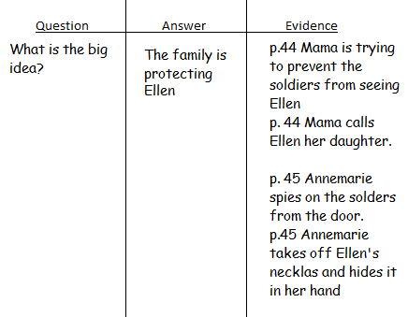
I think the big idea is that the family is protecting Ellen. (write on the chart) I see on page 44 that mama is trying to prevent the soldiers from seeing Ellen. (write on chart) Then on page 44 Mama calls Ellen her daughter.(write on chart)
Active Involvement: (3-5 min)
Now it’s your turn. I’m going to read page 45 and I want you to be alert and look for small details that lead to the big idea that the family is protecting Ellen.
(Read out loud from the doc cam)

Think-Pair-Share
(See examples from page 45 on the H-Chart)
Remember: Readers support their big ideas by being alert to small details.
Link: (1 min)
As you go off to read today I’d like you to make sure you have your reading journal and a pencil with you before you start reading, so that when you get small important details you can, create a quick H-Chart to support your big ideas. Remember, “Readers support their big ideas by being alert to small details.
Mid-Workshop Teaching Point:
Share: (Have book clubs get together to share their big ideas and small details)

Unit 5 Mini Lesson 11

Unit of Study: | Historical Fiction Book Clubs
Goal: | Interpreting complex texts
Teaching point (Kid language!): | Readers fine tune their interpretations of the big ideas by noticing the contrasts and contradictions. 5.RML.5-11 (P. 90 & 97)
Catchy Phrase:
Text: | Number the Stars by Lois Lowry (page 52-53)
Chart: | H-Chart (continue from yesterday if there’s enough space)
Standard: | RL.5.1 Quote accurately from a text when explaining what the text says explicitly and when drawing inferences from the text.  RL.5.3 Compare and contrast two or more characters, settings, or events in a story or drama, drawing on specific details in the text

Mini Lesson: (7-10 minutes total)
Connection: (1-2 min)
Yesterday we worked on creating a H-Chart in order to get down the big ideas from the small details that we alertly found. Today we get to fine tune that work. Kind of like when a guitar players tunes his strings so that just the right sound comes out. Readers fine tune their interpretations of the big ideas by noticing the contrasts and contradictions.
Teach: (4-6 min)
Sometimes we think we know what the big idea is, but then we pay attention to small details and pause and ponder and think, Wait! that doesn’t make sense.

When we read the end of page 52 and page 53 I thought they were going on vacation to the beach, but as I paid attention to details I found contradictions and really had to ponder. Let me show you how as a reader I fine tuned my interpretation of the big ideas by noticing the contrasts and contradictions. (Start an H-chart with the things in black using the book to pull out the evidence. Then continue with the evidence in red and go back and cross out vacation to the beach and add smuggling Ellen out of Denmark).
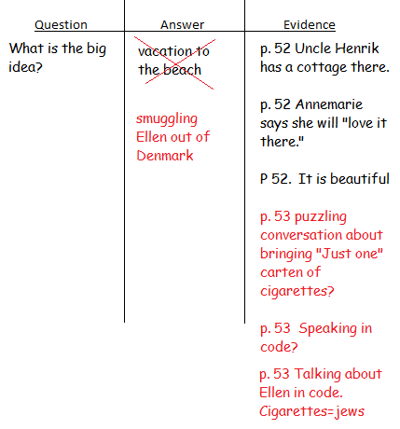

Have you ever put together a puzzle where you didn't have the picture on the top. We think we know what it going to be and were trying to put all the pieces of the puzzle together, then we get this piece that doesn’t quite fit. Sometimes we’re tempted to just leave it out, but it’s an important piece. Then other piece show up and we realize that we thought we were putting together a puzzle of a kitten, but really it was a lion. The same happens as we read: Readers fine tune their interpretations of the big ideas by noticing the contrasts and contradictions.
Active Involvement: (3-5 min)
Now it’s time for you to reflect on what just happened. Have you ever read a book or watched a movie or show where you think you know what is going on and then something happens that throws in a different piece of the puzzle that contradicts what you’ve thought? It was a whole different puzzle
(Think-Pair-Share)

Remember “Readers fine tune their interpretations of the big ideas by noticing the contrasts and contradictions.”
Link: (1 min)
As you go off to dive back into your books, look for contrasts and contradictions that may help you fine tune the big idea that you think is happening. Keep making sure that all the pieces of your puzzle fit into what you think the picture will be when you’re done, and if other pieces show up be flexible and adjust what you puzzle will look like in the end.
Mid-Workshop Teaching Point:
Share: (Continue with H-chart and sharing big ideas with book clubs)

Unit 5 Mini Lesson 12

Unit of Study: | Historical Fiction Book Clubs
Goal: | Interpreting complex texts
Teaching point (Kid language!): | Readers are open to revising their big ideas by listening to others’ ideas. 5.RML.5-12 (P.90 & 98)
Catchy Phrase:
Text: | Number the Stars by Lois Lowry
Chart: | H-chart
Standard: | RL.5.2 Determine a theme of a story, drama, or poem from details in the text, including how characters in a story or drama respond to challenges or how the speaker in a poem reflects upon a topic; summarize the text.  SL.5.1 Engage effectively in a range of collaborative discussions (one-on-one, in groups, and teacher-led) with diverse partners on grade 5 topics and texts, building on others’ ideas and expressing their own clearly.  a. Come to discussions prepared, having read or studied required material; explicitly draw on that preparation and other information known about the topic to explore ideas under discussion.  d. Review the key ideas expressed and draw conclusions in light of information and knowledge gained from the discussions.  SL.5.3 Summarize the points a speaker makes and explain how each claim is supported by reasons and evidence.

Mini Lesson: (7-10 minutes total)
Connection: (1-2 min)
Remember the analogy of we used yesterday about reading a book is like putting together a puzzle where you don't have the finished picture. As you put more and more pieces together you get an idea of the picture but you may be have to revise your big idea. Another way you will revise your big idea is by listening to others.Readers are open to revising their big ideas by listening to others’ ideas.
Teach: (4-6 min)
Let me show you how Readers are open to revising their big ideas by listening to others’ ideas.
I’m going to use an H-Chart to share one of my big ideas for the book “Number the Stars”
(Draw an H-Chart)

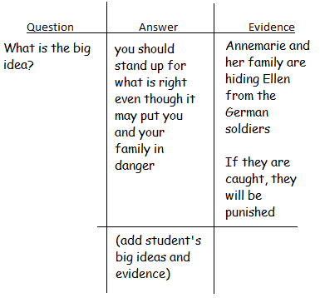

Our question is What is the big idea of this book?
I think one answer is that you should stand up for what is right even though it may put you and your family in danger.
My evidence is that Annemarie and her family are hiding Ellen from the German Soldiers and if they find her there then they too will get punished.

This was just one big idea or theme that I saw throughout the book as we’ve been reading it. Our goal for today is to revise our big ideas by listening to others, so I need your help in this.
Active Involvement: (3-5 min)
Now it is your turn to share your ideas. Get together with a partner and work to find another big idea in “Numbering the Stars”. Don’t forget to find evidence for your big idea.

(Circulate the classroom and look for a variety of big ideas and invite those partners to share them up on the doc cam when everyone has finished.)

Now I am going to invite some students to share their big ideas. Since our goal is to be open to revising their big ideas by listening to others’ ideas, I want you to write down the new big ideas that the students share in your H-chart. If they share the same big idea you have, you may want to add some new evidence that the other student found that you may not have.

Readers are open to revising their big ideas by listening to others’ ideas.
Link: (1 min)
It’s almost time for us to go off and read! Enjoy your books today. As you read think about the big ideas and be prepared to share with your book club and be open to others ideas. It may surprise you what great ideas you and others have.
Mid-Workshop Teaching Point:
Share:
Time to meet in our book clubs, make sure you share your big ideas and be willing to revise your ideas as you listen to others.

Unit 5 Mini Lesson 13
Unit of Study: | Historical Fiction Book Clubs
Goal: | Becoming more complex because we read
Teaching point (Kid language!): | Readers think critically while reading by considering the different points of view of all the characters. 5.RML.5-13 (P. 91 & 98)
Catchy Phrase:
Text: | Number the Stars by Lois Lowry (pages 60-61)
Chart: | Box and T-Chart
Standard: | RL.5.1 Quote accurately from a text when explaining what the text says explicitly and when drawing inferences from the text.  RL.5.3 Compare and contrast two or more characters, settings, or events in a story or drama, drawing on specific details in the text (e.g., how characters interact).

Mini Lesson: (7-10 minutes total)
Connection: (1-2 min)
Listen, Listen, Listen, that’s what we worked on yesterday, listening to each others ideas and sometimes revise our own big ideas of the book. Today, we’re going to learn about point of view and how characters have different points of view because they have different background and how readers think critically while reading by considering the different points of view of all the characters.
Teach: (4-6 min)
Let’s work on this idea that readers think critically while reading by considering the different points of view of all the characters. Remember when Annemarie and Ellen were sitting at the ocean looking out at Sweden. We’re going to re-read this part and create a Box and T-Chart to help us critically think about the different points of view these two girls have. (Read pages 60-61 and fill in part of the box and t-Chart example you see here. Also here is a map that may help them understand that people from Denmark are surrounded by water and normally the Jews came from further inland and haven’t had much experience with the sea).
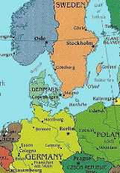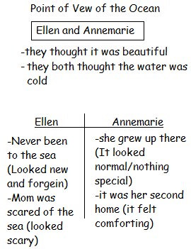

Active Involvement: (3-5 min)
Now I’m going to give you a minute to think about other things that we can add to our chart that will help us understand that these two characters have different points of view.

(Think-Pair-Share) (add to chart)

Remember, “Readers think critically while reading by considering the different points of view of all the characters.”
Link: (1 min)
Now you’re going to have a good long chunk of time to read. As you do so remember that, “Readers think critically while reading by considering the different points of view of all the characters.” Pay close attention to the characters and where they come from, because that will help you better understand them and the decisions they make.
Mid-Workshop Teaching Point:
Share:

Unit 5 Mini Lesson 14
Unit of Study: | Historical Fiction Book Clubs
Goal: | Becoming more complex because we read
Teaching point (Kid language!): | Readers revise their big ideas about characters by considering new understandings around points of view. 5.RML.5-14 (P. 98)
Catchy Phrase:
Text: | Number the Stars by Lois Lowry (pages 75-77 parts)
Chart:
Standard: | RL.5.1 Quote accurately from a text when explaining what the text says explicitly and when drawing inferences from the text.  RL.5.3 Compare and contrast two or more characters, settings, or events in a story or drama, drawing on specific details in the text (e.g., how characters interact).

Mini Lesson: (7-10 minutes total)
Connection: (1-2 min)
Yesterday we worked on, “Readers think critically while reading by considering the different points of view of all the characters.” We’re going to continue today working on points of view, but adding to our understanding that, “Readers revise their big ideas about characters by considering new understandings around points of view.”
Teach: (4-6 min)
I am going to look through Annemarie’s eyes or from her point of view at Mama and Uncle Henrik. She loves them and they love her. They are very close and do not keep secrets. However, on p. 75 we are given a new piece to the puzzle that makes us have to revise our ideas around Mama and Uncle Henrik. (Read the section from the book starting with “you are lying to me”)

Annemarie has to revise her ideas about her uncle and mom because they lied to her. I know that when I find out that someone has lied to me I feel hurt and mistrusting. I am sure that Annemarie is feeling the same. She probably is wondering if she can trust her uncle and wondering what other lies he has been keeping from her. She probably is wondering if he really loves her.

As we read on we revise the big ideas about characters by considering new understandings around points of view.
Active Involvement: (3-5 min)
Now it’s your turn, on the doc cam I have a part of page 77. Let me read this part. (read from “You guessed correctly… until Do you understand?)

Now think about how this new piece of information about Annemarie's uncle and mother lying to her. What does Annemarie understand now about her mom, and how that effect her point of view?

(Think-Pair-Share)

Most things in life need to be revised, just as, “Readers revise their big ideas about characters by considering new understandings around points of view.”
Link: (1 min)
We’re still working on putting all the puzzle pieces together. Even as we re-read and analyze what is happening in the book, we continue revising our ideas about the characters, by considering new understandings around points of view. As you go off to read today, see if your ideas change as you consider new insights of the characters points of view.
Mid-Workshop Teaching Point:
Share:

Unit 5 Mini Lesson 15
Unit of Study: | Historical Fiction Book Clubs
Goal: | Becoming more complex because we read
Teaching point (Kid language!): | Readers find huge meanings in book by investigating who has power and in what form and how it shifts. 5.RML.5-15 (P. 91 & 98)
Catchy Phrase:
Text: | Number the Stars by Lois Lowry p. 81 and 83
Chart: | H- Chart
Standard: | RL.5.1 Quote accurately from a text when explaining what the text says explicitly and when drawing inferences from the text.

Mini Lesson: (7-10 minutes total)
Connection: (1-2 min)
Yesterday, we worked on revising our big ideas about characters by considering new understandings around points of view. It’s not always easy to do this, so keep working at it as you read your books.
Today, we’re going to find huge meanings in book by investigating who has power and in what form and how it shifts. Power is not always obvious to see, in the book, “Number the Stars,” we have lots of examples of how power shifts. We’re going to use some examples in the book to help us understand that Readers find huge meanings in books by investigating who has power and in what form and how it shifts.
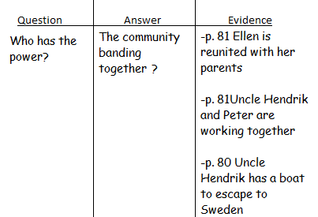
Teach: (4-6 min)
Let me read this passage to you and then we will see who has the power. Remember, it may not be obvious. Think about who is getting what they want as the person who has the power? (Read the last paragraph on p.80 and 81.)

First off, Ellen and her family get what they want because they are reunited. But that is also what Annemarie’s family wants too. We see that Mama, Uncle Henrik, and Peter are working together which I know there is power in working together. And Uncle Henrik had a means of escape, his boat, which also gave him power. No one person has the power but as they band together, this community of people together have great power.

Readers find huge meanings in book by investigating who has power and in what form and how it shifts.
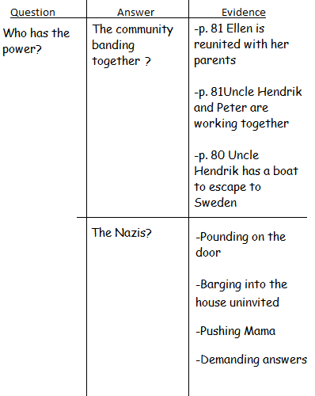
Active Involvement: (3-5 min)
Now it’s your turn to investigate who has the power and find evidence to support your ideas. (Place page 83-84 on the doc cam) I’m going to read when the soldiers came into the funeral. (Start reading at She heard… and finish on the next page at entered the living room).

Think-pair-Share (Add to the chart)

Don’t forget: “Readers find huge meanings in book by investigating who has power and in what form and how it shifts.”

Looking at our chart we see that there is a battle for power here. It appears that the Nazis have the powers, but hidden in the wood works you see that the community has banded together and holds its own power. Who will have the power at the end?? Keep searching for evidence of how power shifts.
Link: (1 min)
It’s your turn to return to your books and enjoy the stories you’re reading. Today as your reading pay special attention to who has the power and jot down a note or two of what type of power certain characters have and does it shift.

Mid-Workshop Teaching Point:
Share:
It’s time to share in our book clubs about who has power in your books and what type of power certain characters have. Also spend a minute discussing if the power shifts during the books.

Unit 5 Mini Lesson 16
Unit of Study: | Historical Fiction Book Clubs
Goal: | Becoming more complex because we read
Teaching point (Kid language!): | Readers spark new ideas by reading non-fiction about the same time period. 5.RML.5-16 (P. 91 & 98)
Catchy Phrase:
Text: | Number the Stars by Lois Lowry, Kidbiz article: Remembering the Holocaust (see attached)
Chart:
Standard: | RI.5.1 Quote accurately from a text when explaining what the text says explicitly and when drawing inferences from the text.

Mini Lesson: (7-10 minutes total)
Connection: (1-2 min)
We’ve been working on many things as readers, lately we’ve been working on power, who has it, in what form, and how it has shifted. Today we’re going to look at a chart that will give us more information on who has power. Especially in historical fiction reading non-fiction texts during the same time period helps us spark new ideas. Readers spark new ideas by reading non-fiction about the same time period.
Teach: (4-6 min)
I found this graph on about the number of Jews that died in World War II on Wikipedia (Project for the class to see http://en.wikipedia.org/wiki/World_War_II_casualties)
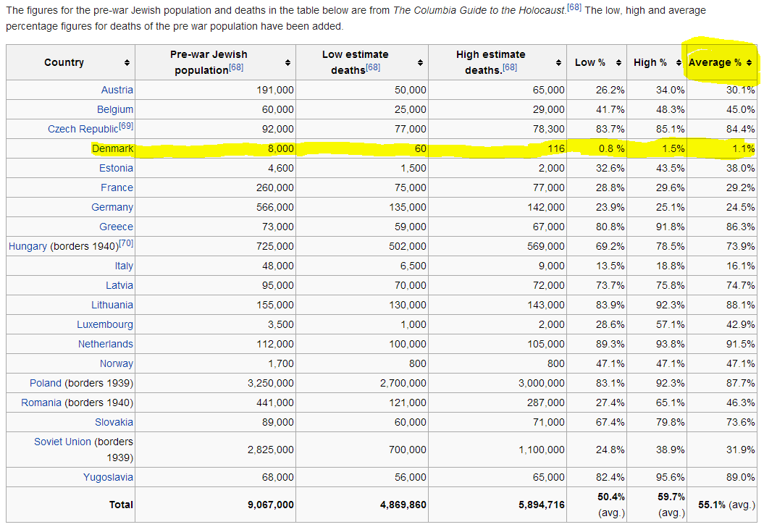
Let’s look at this graph. When I looked at the average percent of Jews killed in Denmark, I was surprised. It was only 1.1%, that is really low compared to Poland where 87.7% died. This sparks a new idea in my head. Was one of the reasons why Denmark has such a low percentage was that the community banded together to protect them and was able to get them safely across to Sweden? Really reading non-fiction during the same time period can give great sights or lead you to read your historical fiction books a little different.
Active Involvement: (3-5 min)
Nonfictions can help spark big ideas that we see in our book. Lets look at this passage from a Kidbiz article and see what this big ideas it sparks: (Project this for the class and read together. You can find the full article at the end of this lesson.)

In 1941, Hitler declared that all Jews were to be killed. The following year, Nazi officials planned what they would do to the Jews. Those who were unfit to work in the concentration camps were killed right away. The others would work in the camps and were killed later. Nazis murdered 5.9 million Jews and 5 million other people. Many were killed by fire or by gas. Others starved to death or died of disease. The remaining people were due to be killed when troops freed them in 1945. In all, two-thirds of European Jews died at the hands of the Nazis.

Turn and talk to your partner about what this tells you about World War II? Doe it give you any new insights into “Number the Stars”?
Readers spark new ideas by reading non-fiction about the same time period.
Link: (1 min)
Now it’s your turn to read. I’ve supplies some nonfiction books and articles that you may read once you’re done with your section of reading for the day. Remember, “Readers spark new ideas by reading non-fiction about the same time period.”
Mid-Workshop Teaching Point:
(You may want to give your class time to look things up in groups or in the library, just be careful some pics can pop up and be questionable)
Share:
(If students had a chance to read non-fiction, you may want to give them a chance to talk)
Remembering the Holocaust
Kidbiz Article: Achieve3000, March 13, 2006). "Holocaust" means " destruction of human life." For many people, the word will be forever linked with the 1930s and 1940s. During that period, millions of Jews, gypsies, mentally ill, and others in Europe were rounded up. They were murdered. The horrifying event was worse than any other example of its kind. It became known as "The Holocaust."

Why and How the Holocaust Occurred
The Holocaust was rooted in a history of hatred against Jews in Europe. By the 1930s, the Jewish people had been making valuable contributions to European society for 2,000 years. Still, prejudice had developed because many people did not like the Jewish religion. Others did not like that Jews were successful. They hated the Jews for no reason. They wrongly believed that Jews were causing the problems in their countries.

Germany was on the losing side in World War I. The country was in ruins. Many people were resentful [[6]] and looking for someone to blame. Many chose to blame the Jews, even though there was no reason to believe that Jews had done anything wrong. A small a group of people called the Nazis promised to prevent Jews from "ruining" German society. By 1933, Nazi leader Adolph Hitler was head of Germany.

The Nazis began treating Jews differently from other people in the country. They told people not to shop at Jewish-owned businesses. They took away the rights of all German Jews. Because of this, many Jews fled Germany to other countries in Europe and North America. Meanwhile, the Nazis began trying to take over all of Europe. The German army began attacking country after country.

When Germany invaded Poland in 1939, France and England declared war on Germany to try to stop Hitler's advances. The resulting war became known as World War II. During the war, an alliance was formed between England, France, and the U.S. (which entered the war in 1941). These countries fought against Germany, which had been joined by Italy and Japan. Throughout the war, the Nazis continued their terrible actions against Jews.

Concentration Camps
The Nazis believed that they were better than other people. Along with Jews, the Nazi targeted many other groups of people that they considered to be "lesser" human beings. They began removing these people from their homes to separate them from the rest of the population. In many nations, these people were sent to work camps in Eastern Europe, known as concentration camps. Families were split apart. Children were forced to live on their own in the camps. People in the camps were forced to perform slave labor. They lived in crowded, dirty conditions with little food. Disease was everywhere.

In 1941, Hitler declared that all Jews were to be killed. The following year, Nazi officials planned what they would do to the Jews. Those who were unfit to work in the concentration camps were killed right away. The others would work in the camps and were killed later. Nazis murdered 5.9 million Jews and 5 million other people. Many were killed by fire or by gas. Others starved to death or died of disease. The remaining people were due to be killed when troops freed them in 1945. In all, two-thirds of European Jews died at the hands of the Nazis.

Who Helped?
Why weren't people willing to help the Jews? There were many reasons. Some people agreed with the Nazis. Others were afraid what might happen if they opposed them. Still, there were rare individuals who had the courage to stand up to Hitler. Here are some examples of those people.

Witold Pilecki of Poland was one of those people. Pileccki volunteered to be sent to a concentration camp. He wanted to fight the Nazis from within the camp. Once inside, Pilecki set up a secret group called the ZOW. The group worked to bring in help from outside the camp. It brought in food and clothing, as well as news from the outside world. In 1943, Pilecki escaped from Auschwitz with secret German papers. He was later arrested and spent the rest of the war in a German prison.

Chiune Sugihara was from Japan. He also helped thousands of people flee to safety. During World War II, Sugihara wrote thousands of visa for the Jews so they could leave the country. Often, he wrote the visas against the orders of his own government.

Unit 5 Mini Lesson 17

Unit of Study: | Historical Fiction Book Clubs
Goal: | Becoming more complex because we read
Teaching point (Kid language!): | Readers notice common themes across texts by comparing and contrasting people, places, events and ideas. 5.RML.5-17 (P. 91,92, & 98, 99)
Catchy Phrase:
Text: | Number the Stars by Lois Lowry, Dear Mr. Henshaw
Chart: | Box & T-Chart
Standard: | RL.5.1 Quote accurately from a text when explaining what the text says explicitly and when drawing inferences from the text.  RL.5.3 Compare and contrast two or more characters, settings, or events in a story or drama, drawing on specific details in the text (e.g., how characters interact).

Mini Lesson: (7-10 minutes total)
Connection: (1-2 min)
Hopefully you had a good time looking at some nonfiction articles yesterday, and increasing your knowledge of what is going on in the world around the time the, “Number the Stars” took place. Right now we’re going to use the box and T-chart, Yes, that means we will be comparing and contrasting something. It’s important to understand that, “Readers notice common themes across texts by comparing and contrasting people, places, events and ideas.” Using a box and T-Chart will help us see common themes across books.
Teach: (4-6 min) (You may choose another book, just keep in mind it’s easier to have your box and T-chart done prior to the lesson to get the greatest impact)
Dust off your brain and remember at the beginning of the year we read Dear Mr. Henshaw. Well we’re going to compare and contrast that book with our current book Number the Stars.

I’m going to begin my box and T-Chart they thinking about how these two books are alike and different. (Start a box and T-chart, see example below, only do part and leave part for the active engagement).

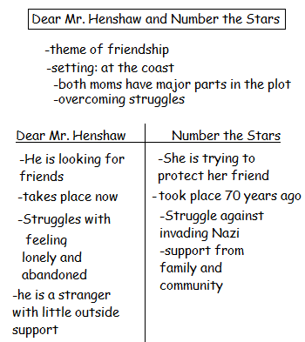

Readers notice common themes across texts by comparing and contrasting people, places, events and ideas
Active Involvement: (3-5 min)
Now it’s your turn to help me add to this chart.
Think-Pair-Share (Chart ideas)
Remember: Readers notice common themes across texts by comparing and contrasting people, places, events and ideas
Link: (1 min)
As you go read today think about how your books theme compare with our class took “Number the Stars.” Take a few quick notes in your journal, because later during the share your book club will get together to discuss this. Don’t forget, “Readers notice common themes across texts by comparing and contrasting people, places, events and ideas.”
Mid-Workshop Teaching Point:
Share:
Now I’m going to give you a few minutes in your book clubs to share how your book and our class book have similar themes by comparing the people, places, events, and ideas.

Unit 5 Mini Lesson 18
Unit of Study: | Historical Fiction Book Clubs
Goal: | Becoming more complex because we read
Teaching point (Kid language!): | Readers express big ideas by making allusions to one character by basing it off another person. 5.RML.5-18 (P. 92 & 99)
Catchy Phrase:
Text: | Number the Stars by Lois Lowry
Chart:
Standard: | RL.5.1 Quote accurately from a text when explaining what the text says explicitly and when drawing inferences from the text.  RL.5.3 Compare and contrast two or more characters, settings, or events in a story or drama, drawing on specific details in the text (e.g., how characters interact).

Mini Lesson: (7-10 minutes total)
Connection: (1-2 min)
We are almost done with this unit, and we’ve learned so much about historical fiction, and how we can grow as readers.

Readers express big ideas by making allusions to one character by basing it off another character.
Teach: (4-6 min)
Sometimes we have so many ideas in our head about the characters in our book, that we are lost for words, we don’t really know what to say. Often authors will use allusions to help us understand the big idea by comparing one character with another person. They do this by creating allusions.
Allusions is like creating a metaphor by comparing a character in the book with another person. “I was surprised his nose was not growing like Pinocchio’s.” This refers to the story of Pinocchio, where his nose grew whenever he told a lie.

Here are some sentences frames that I’d like to show you how to use.

___ is as ___ as Annemarie: (student name) is as brave/helpful/mature as Annemarie.
____ is as ___ as Kristi: (student name) is as naive/immature/rude as Kristie.
____is as ___as Uncle Henrik: (student name) is as wise/sneaky/sly/brave as Uncle Henrik.

Readers express big ideas by making allusions to one character by basing it off another person.
Active Involvement: (3-5 min)
Now it’s your turn, be nice! Think about yourself, how could you compare yourself to one of the characters in this story.

(Think-Pair-share)

Readers express big ideas by making allusions to one character by basing it off another person.
Link: (1 min)
As you read, try to come up with one allusion in your story that you can share with your book club. Remember, “Readers express big ideas by making allusions to one character by basing it off another person.”
Mid-Workshop Teaching Point:
Share:
Get in your book club and share your allusions.

Unit 5 Mini Lesson 19
Unit of Study: | Historical Fiction Book Clubs
Goal: | Becoming more complex because we read
Teaching point (Kid language!): | Readers adapt their world view by learning from the choices the characters make. 5.RML.5-19 (P. 92 & 99)
Catchy Phrase: | “So, what?”
Text: | Number the Stars by Lois Lowry
Chart:
Standard: | RL.5.1 Quote accurately from a text when explaining what the text says explicitly and when drawing inferences from the text.  RL.5.2 Determine a theme of a story, drama, or poem from details in the text, including how characters in a story or drama respond to challenges or how the speaker in a poem reflects upon a topic; summarize the text.

Mini Lesson: (7-10 minutes total)
Connection: (1-2 min)
Now that we have finished our books we come to a crossroads. We can either put down this book and get the next book forgetting what we have read or we can look for meaning in this book. I like to ask “So what?” So what did we learn? So what was the point of reading this? So what was the point of the author in writing this?

Readers adapt their world view by learning from the choices the characters make.
Teach: (4-6 min)
These are big questions to ask and overwhelming so lets zero in on one pivotal event in the story.

So what can we learn from Annemarie’s decision, in a moment of high stakes, to rip off her best friend’s Star of David necklace, which identifies Ellen’s Jewishness and now Potentially marks Annemarie, too?

This is a deep question that involves some quiet think time. Lets all think about this silently as I read it again. (read it slowly)
I think this show amazing bravery and true loyalty. I think of my best friend and wonder if I would put my life at risk to save her the same way Annemarie did. Her actions inspire me to be more like her.

Readers adapt their world view by learning from the choices the characters make.
Active Involvement: (3-5 min)
What other things have you learned about how Annemarie’s choices? (Think-Pair-Share)

How does what you learned from her help you change how you act towards other people who are different than you? (Think-pair-Share)

I have learned to be more accepting and as a Reader have adapted my world view by learning from the choices that Annemarie and her family made.
Link: (1 min)
Today is our last day in this unit, so finish up your books and we will meet for the last time in our book clubs. As you read think about how, “Readers adapt their world view by learning from the choices the characters make..”
Mid-Workshop Teaching Point:
Share:
Today you will wrap up your book clubs, so make sure you finish by talking about how readers adapt their world view by learning from the choices the characters make.

